Gaining Access — Lesson Plan
Classification: UNCLASSIFIED

1. Administrative and metadata

1.1 Lesson title
Gaining Access

1.2 Module length
60 minutes (1 hours)
Schedule slot is 60 minutes. Content-guide ~90 minutes is the lecture before the gaining-access labs.

1.3 Terminal and enabling learning objectives
- TLO-4: At the end of the Counterstrike Operator Course, students will be able to rapidly access and effect adversary infrastructure
- ELO-36: Identify initial access techniques from MITRE attack
- ELO-38: Recognize initial access opportunities
- ELO-39: Understand how to gain initial access by exploiting vulnerabilities in public-facing applications (T1190).
- ELO-40: Understand how to gain initial access through compromised external remote services (T1133).
- ELO-41: Understand how to gain initial access using valid but compromised user accounts (T1078).
- ELO-42: Understand how to gain initial access through internal spear phishing attacks (T1534).
- ELO-49: Recall and identify different types of vulnerabilities

1.4 Prerequisites
- B02.M02: Open-Source Ecosystem

2. Personnel, range, and environment

2.1 Instructor and cadre
- 1 × instructor (required)
- 0 × range_engineer (not_applicable: Lecture Module; no range engineer required)
- 0 × auditor (not_applicable: Not used by this course)
- 0 × oversight_officer (not_applicable: Not used by this course)

2.2 Materials and resources
Instructor resources and pre-class preparation
- Classroom projector and screen; whiteboard for the opening contract
- Parent or sibling briefs listed in this Module folder
- Live tabs and references already named in this file's header
- Do not project flags, tokens, or answer-key values
Student resources and environment
- Student brief, student guide, or homework file in this Module folder when present
- Assigned range, workstation, or lab stack named in the student-facing file
- No extra kit beyond what the student-facing file already lists

3. Assessment and evaluation
ELO | Method | Related Module | Criteria
ELO-36 | in-class Q&A | — | In-class questions and check on learning in the content guide.
ELO-38 | in-class Q&A | — | In-class questions and check on learning in the content guide.
ELO-39 | in-class Q&A | — | In-class questions and check on learning in the content guide.
ELO-40 | in-class Q&A | — | In-class questions and check on learning in the content guide.
ELO-41 | in-class Q&A | — | In-class questions and check on learning in the content guide.
ELO-42 | in-class Q&A | — | In-class questions and check on learning in the content guide.
ELO-49 | in-class Q&A | — | In-class questions and check on learning in the content guide.

4. Instructional delivery

4.1 Opening, attention grabber, and motivator

Option 1 (Interactive / Whiteboard / Kinesthetic)
- Say: "Recon told you what is exposed and what might be weak."
- Do: Put the lesson contract on the board. Keep products from the prerequisite Module available.
- Ask (Q): What is the difference between knowing a CVE exists and having a usable session?
- Expected Response (A): Facilitation. Use the Say/Do already on this row; do not force a single keyed answer.

Option 2 (Digital Slide / Virtual / Slide Deck)
- Say: "Recon told you what is exposed and what might be weak."
- Show: The title slide and lesson objectives.
- Do: Confirm stations can open the required tool or file before the first teaching row.
- Ask (Q): What is the difference between knowing a CVE exists and having a usable session?
- Expected Response (A): Facilitation. Use the Say/Do already on this row; do not force a single keyed answer.

4.2 Side-by-side table of instruction
Visual / Slide Asset | Instructional Delivery & Instructor Notes
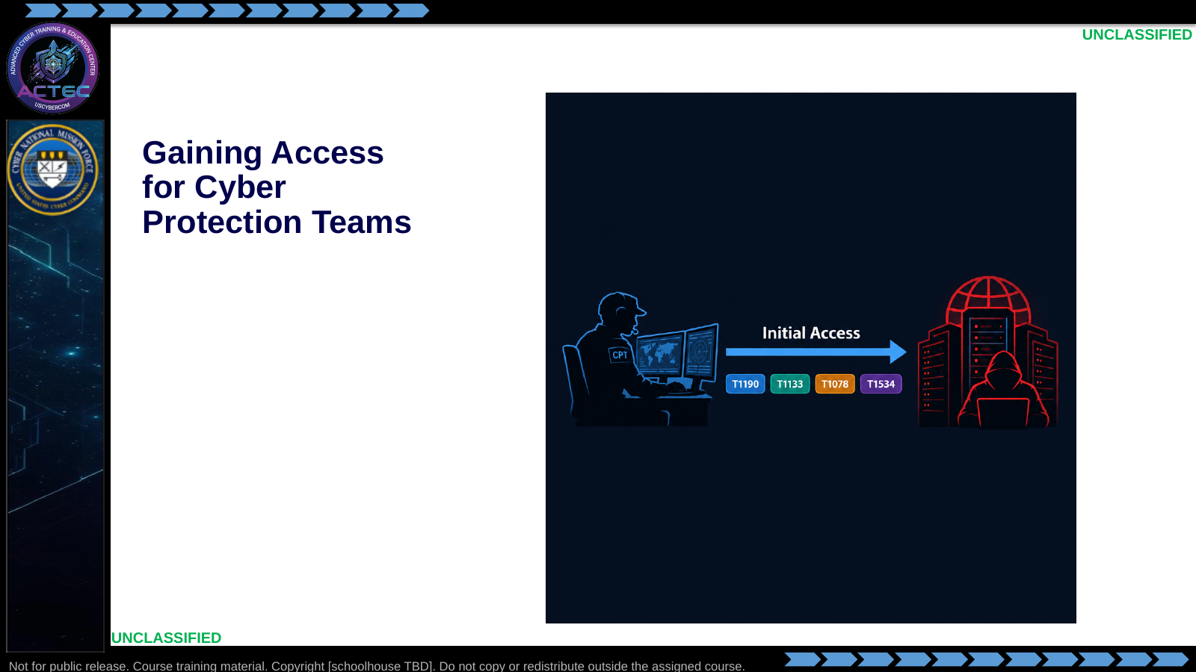  Slide 1: Gaining Access for Cyber Protection Teams  Duration: 2 min | Say: - "Recon told you what is exposed and what might be weak."  - "This lesson turns that evidence into a controlled foothold."  - "Objectives are next; they are the contract for this block."  Show: - Hold on the access arrow and technique tags long enough for students to orient, then advance.  Do: - Ask: "What is the difference between knowing a CVE exists and having a usable session?"  - Take one answer; return to it during the access pipeline.  Ask (Q): What is the difference between knowing a CVE exists and having a usable session?  Expected Response (A): Facilitation. Use the Say/Do already on this row; do not force a single keyed answer.
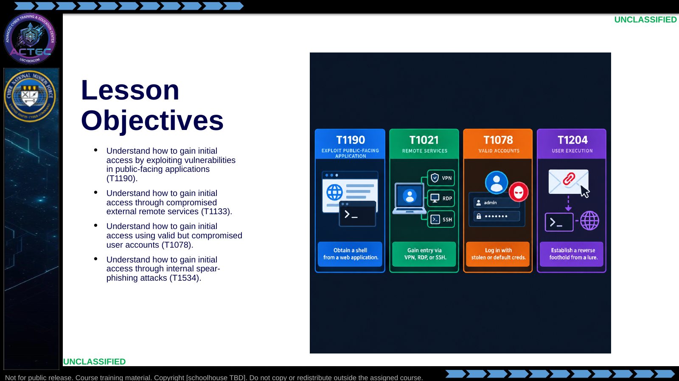  Slide 2: Lesson Objectives  Duration: 2 min | Say: - "Read these objectives as written—they are the contract for this block."  - "T1190: gain initial access by exploiting public-facing applications."  - "T1133: gain initial access through compromised external remote services."  - "T1078: gain initial access using valid but compromised user accounts."  - "T1534: gain initial access through internal spear-phishing attacks."  - "This block moves from evidence-driven access selection through four techniques, then combines paths and documents the handoff before labs."  - "By the end, you should pick a technique from recon evidence, not from habit."  Show: - Walk the four cards left to right while pointing at each matching bullet.  Do: - Tell students to write the four IDs in their notebook; they will map lab work to them later.  Ask (Q): What is the operational takeaway from this row?  Expected Response (A): Facilitation. Restate the Say/Do in operator terms. Do not invent a new teaching point.
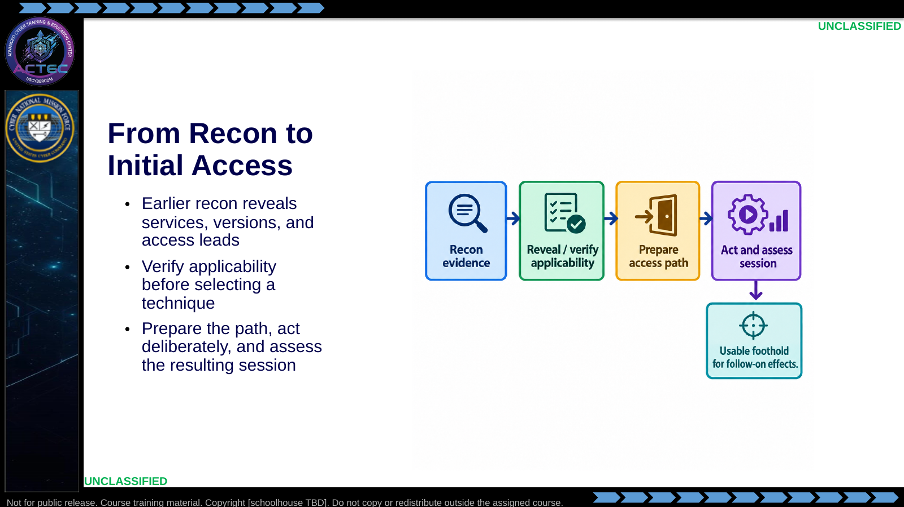  Slide 3: From Recon to Initial Access  Duration: 2 min | Say: - "This block is the transition from characterizing a target to establishing a controllable foothold."  - "Active recon provided service and version evidence; open-source research showed how to find candidate weaknesses."  - "Do not treat a banner or a CVE listing as proof that a path will work."  - "Use the sequence: observe, reveal or verify applicability, prepare, then act and assess the session."  - "A foothold enables later effects; it is not the end state."  Show: - Walk the process left to right and point out the assessment step after execution.  Do: - Ask: "Where do access attempts most often fail: applicability, preparation, or execution?"  - Take two answers.  Ask (Q): Where do access attempts most often fail: applicability, preparation, or execution?  Expected Response (A): Facilitation. Use the Say/Do already on this row; do not force a single keyed answer.
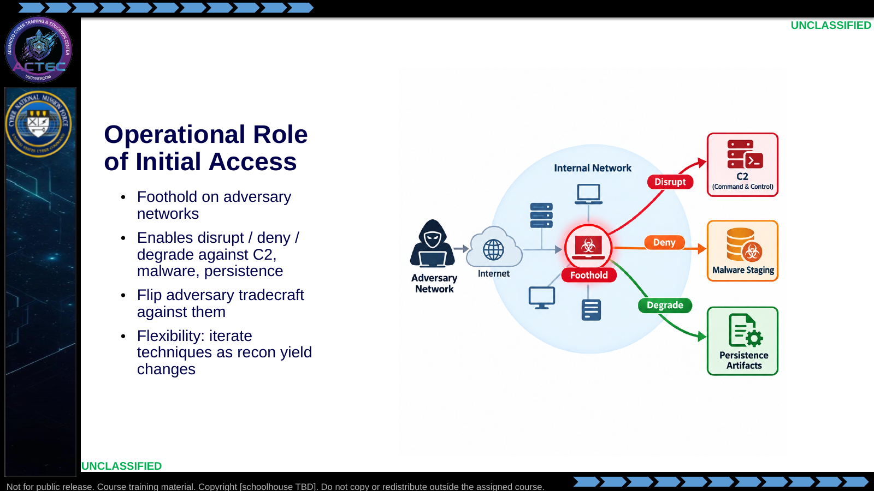  Slide 4: Operational Role of Initial Access  Duration: 2 min | Say: - "Initial access is the beachhead."  - "Without it, effects stay theoretical."  - "With it, you can disrupt C2, deny malware utility, or strip persistence."  - "You are flipping the same techniques they use—on their infrastructure."  - "Stay flexible: if one path dies, another may still work."  Show: - Point to the foothold.  - Point to each effect arrow.  Do: - Ask: "If the public web exploit is patched mid-mission, what do you check next?"  Ask (Q): If the public web exploit is patched mid-mission, what do you check next?  Expected Response (A): Facilitation. Use the Say/Do already on this row; do not force a single keyed answer.
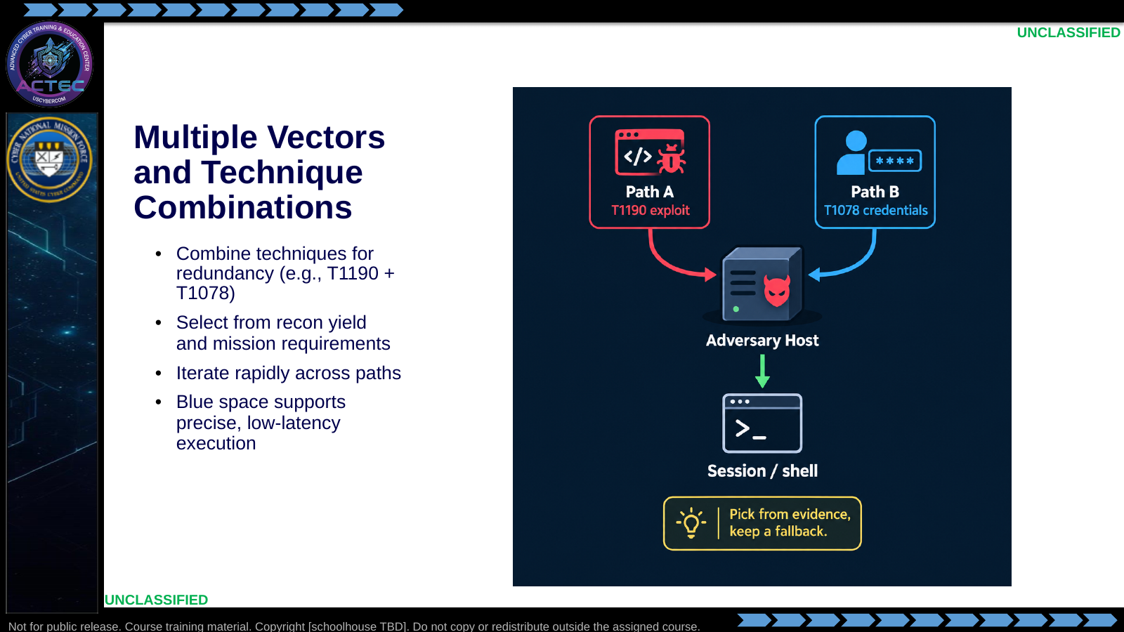  Slide 5: Multiple Vectors and Technique Combinations  Duration: 2 min | Say: - "Do not marry one technique."  - "Typical pattern: exploit for speed, credentials as fallback."  - "Selection follows what recon actually produced."  - "If research and verification support a reliable module, lead with T1190."  - "If you already have working creds from malware analysis, lead with T1078."  - "Blue-space vantage lets you iterate without building covert launch infrastructure first."  Show: - Trace Path A and Path B to the same session.  Do: - Pair students: one names a primary path, the other names a fallback from the same recon packet.  Ask (Q): What is the operational takeaway from this row?  Expected Response (A): Facilitation. Restate the Say/Do in operator terms. Do not invent a new teaching point.
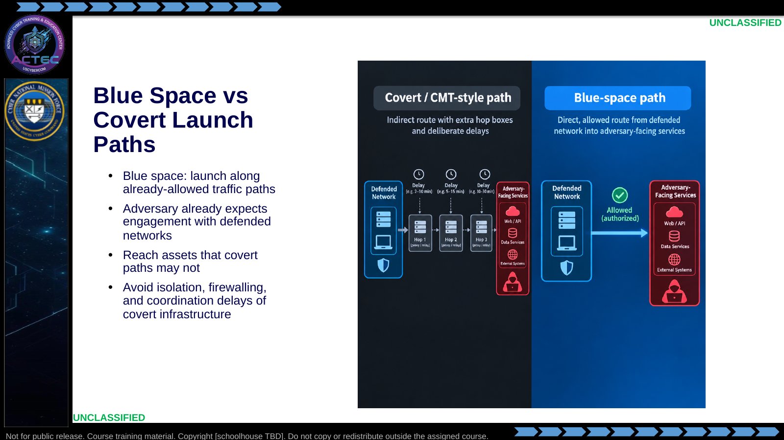  Slide 6: Blue Space vs Covert Launch Paths  Duration: 2 min | Say: - "Positioning is part of the technique."  - "From blue space you often ride paths the adversary already trusts or probes."  - "That can reach assets blocked to a cold covert launch."  - "You also skip much of the setup tax of building and coordinating covert infrastructure."  - "This is an execution advantage, not a license to be noisy."  Show: - Contrast the multi-hop covert path with the direct blue-space path.  Do: - Ask: "What operational delay does a covert path introduce that blue space can avoid?"  Ask (Q): What operational delay does a covert path introduce that blue space can avoid?  Expected Response (A): Facilitation. Use the Say/Do already on this row; do not force a single keyed answer.
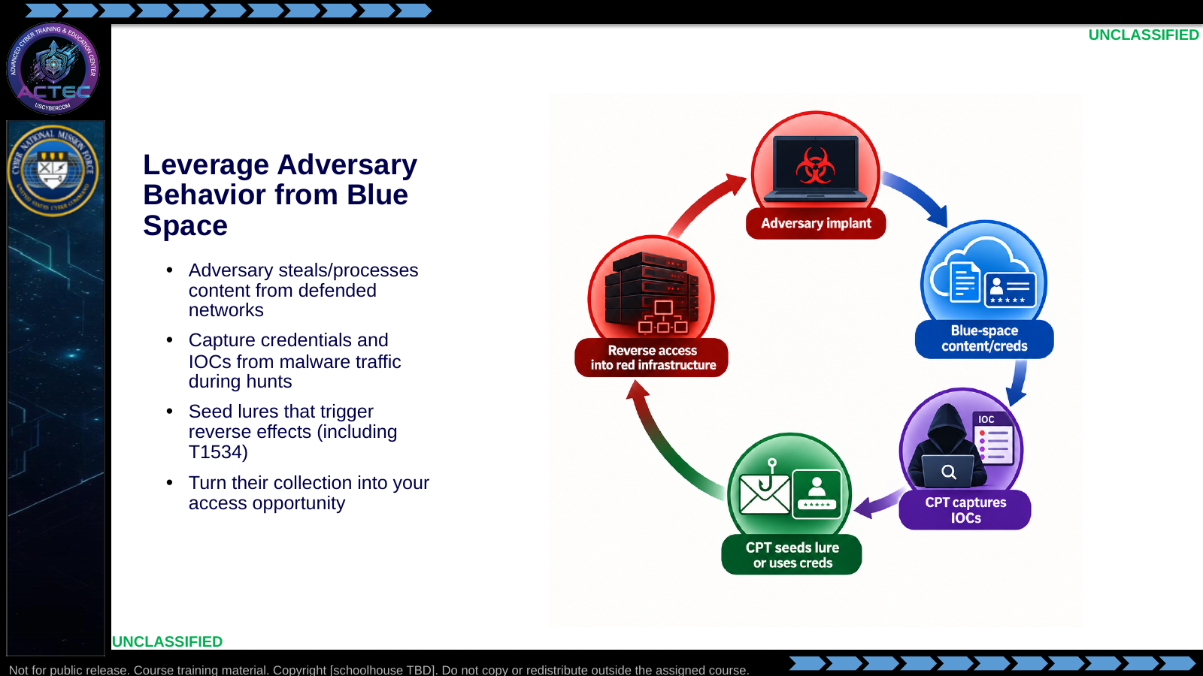  Slide 7: Leverage Adversary Behavior from Blue Space  Duration: 2 min | Say: - "They come to you for data."  - "Hunt traffic and samples for credentials and IOCs."  - "Those artifacts fuel T1078 and exploit matching."  - "You can also plant lures they will steal—setting up T1534."  - "Their collection habit becomes your access method."  Show: - Walk the cycle clockwise.  Do: - Ask for one blue-space artifact that could become an access input (cred, URL, upload path, version string).  Ask (Q): What is the operational takeaway from this row?  Expected Response (A): Facilitation. Restate the Say/Do in operator terms. Do not invent a new teaching point.
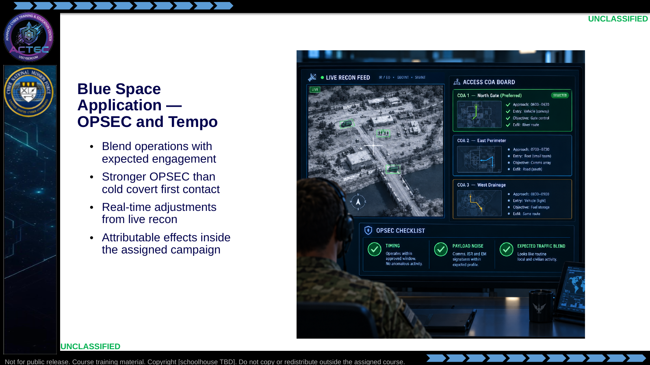  Slide 8: Blue Space Application — OPSEC and Tempo  Duration: 2 min | Say: - "Blue space lets you look like traffic they already process."  - "That improves OPSEC versus a brand-new covert launch signature."  - "You can retune modules and targets from live recon without waiting on new infrastructure."  - "Effects remain tied to the assigned campaign and target set."  - "We will apply this lens to each technique."  Show: - Point to OPSEC checklist and live-recon feed.  Do: - Tell students: "For every technique today, ask what blue space uniquely enables."  Ask (Q): What is the operational takeaway from this row?  Expected Response (A): Facilitation. Restate the Say/Do in operator terms. Do not invent a new teaching point.
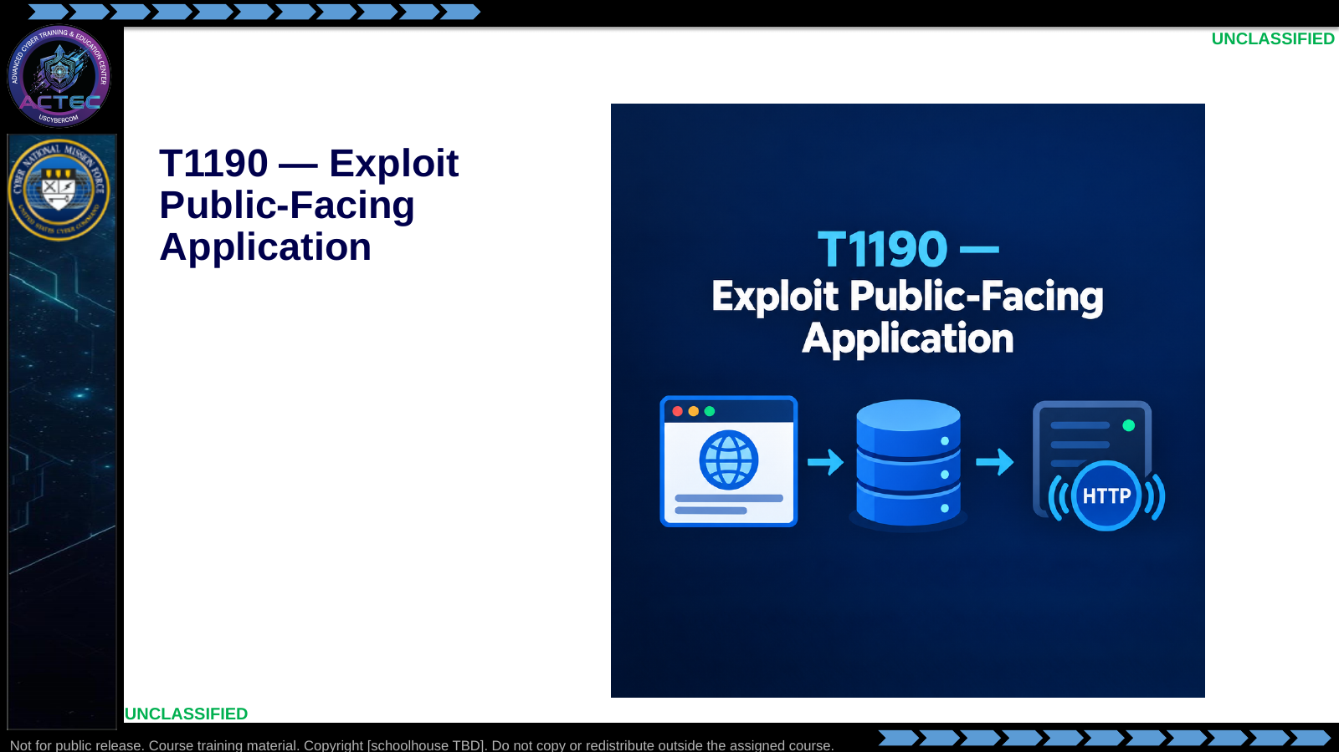  Slide 9: T1190 — Exploit Public-Facing Application  Duration: 2 min | Say: - "First technique: public-facing application exploitation."  - "The next slide applies the definition and operational value."  Show: - Hold on the technique title and service icons, then advance.  Do: - None required beyond the transition.  Ask (Q): What is the operational takeaway from this row?  Expected Response (A): Facilitation. Restate the Say/Do in operator terms. Do not invent a new teaching point.
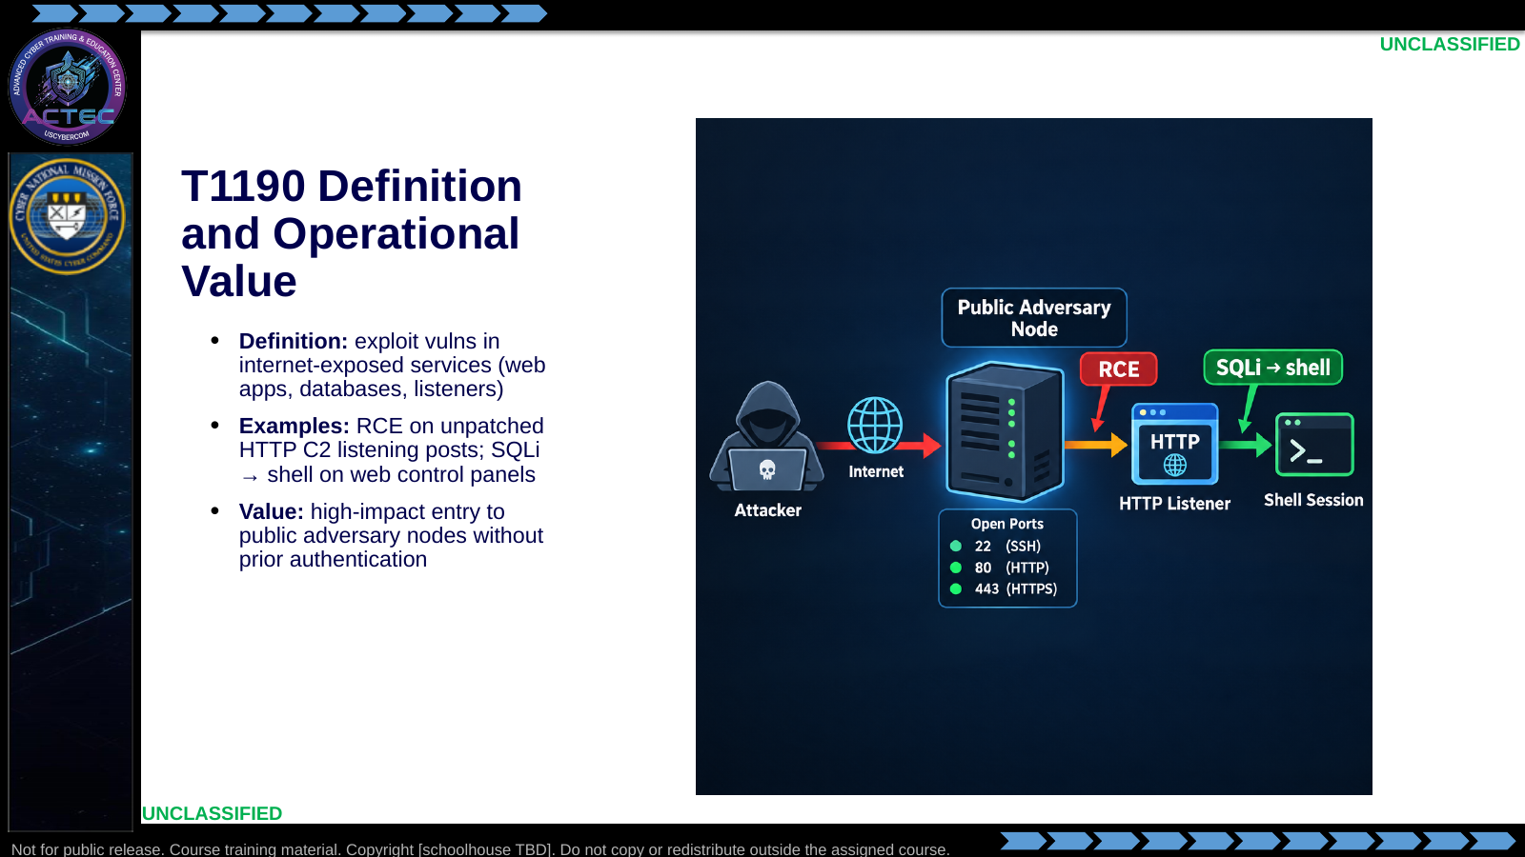  Slide 10: T1190 Definition and Operational Value  Duration: 2 min | Say: - "T1190 means you exploit the application or service itself."  - "This is a reminder of the vulnerability-research workflow; the focus here is applying it to initial access."  - "Classic counterstrike targets: HTTP listening posts and web management panels."  - "RCE gives you code execution."  - "SQLi can dump data or chain to a shell."  - "Operational value is speed: no credential hunting required if the vuln is remote and unauthenticated."  Show: - Trace exploit → shell on the graphic.  Do: - Ask: "Why is an unauthenticated RCE usually preferred over an authenticated one for first entry?"  Ask (Q): Why is an unauthenticated RCE usually preferred over an authenticated one for first entry?  Expected Response (A): Facilitation. Use the Say/Do already on this row; do not force a single keyed answer.
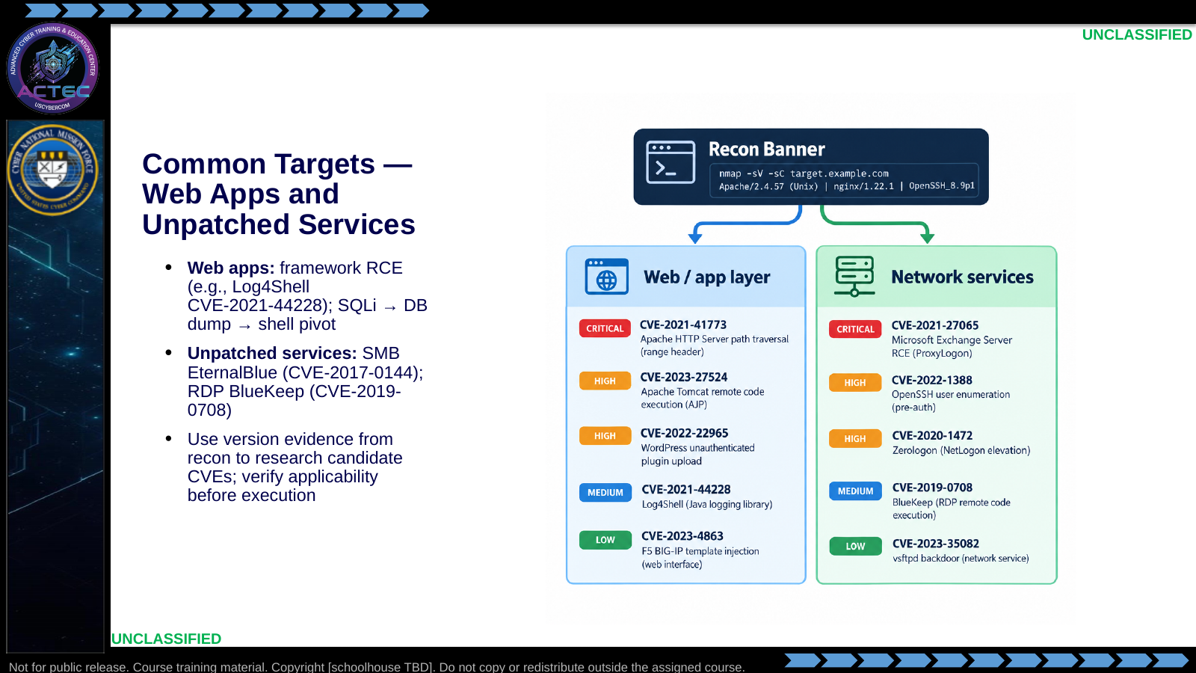  Slide 11: Common Targets — Web Apps and Unpatched Services  Duration: 2 min | Say: - "Common does not mean only."  - "Web frameworks inherit famous RCEs—Log4Shell is the teaching example."  - "SQLi remains a path when the app talks to a database carelessly."  - "Legacy service vulns still appear on neglected adversary hosts: EternalBlue, BlueKeep."  - "Your recon banner is the index key into those CVEs."  Show: - Point from banner strip to each CVE example.  Do: - Ask which of these they touched in Metasploit practice or vulnhub-style targets.  Ask (Q): What is the operational takeaway from this row?  Expected Response (A): Facilitation. Restate the Say/Do in operator terms. Do not invent a new teaching point.
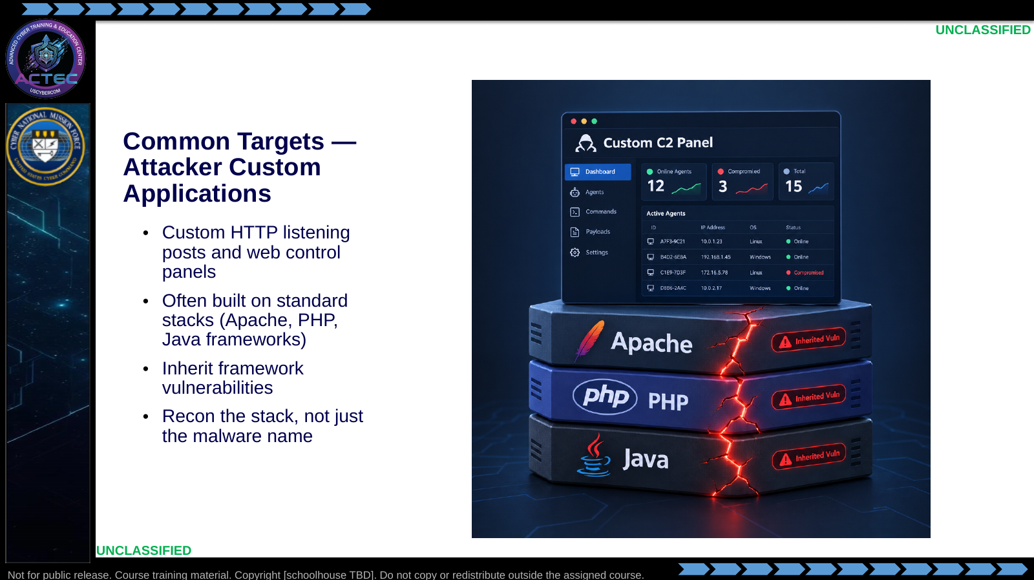  Slide 12: Common Targets — Attacker Custom Applications  Duration: 2 min | Say: - "Adversary tooling is often custom at the top and ordinary underneath."  - "Listening posts and botnet panels reuse Apache, PHP, Java, nginx."  - "Exploit the framework they inherited, not a mythical unique binary only."  - "Version the stack components the same way you version any public app."  Show: - Point to the custom UI, then to the underlying stack cracks.  Do: - Ask: "If the panel title is unique but the Server header says nginx/1.18, what do you research first?"  Ask (Q): If the panel title is unique but the Server header says nginx/1.18, what do you research first?  Expected Response (A): Facilitation. Use the Say/Do already on this row; do not force a single keyed answer.
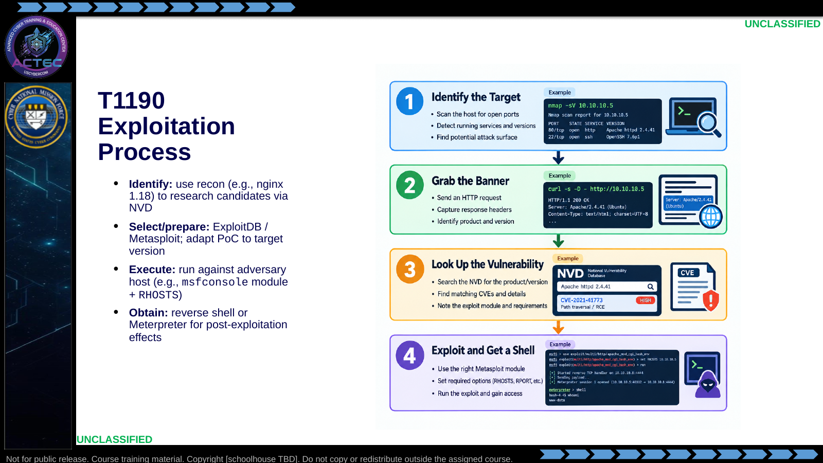  Slide 13: T1190 Exploitation Process  Duration: 2 min | Say: - "This repeats the vulnerability-research workflow from Lessons 2.3 and 2.5, now applied to access."  - "Identify: use the banner as a research lead, then verify the target's conditions against authoritative advisory and vendor evidence."  - "NVD and ExploitDB can accelerate triage; SI can summarize or organize leads, but neither establishes exploitability. Verify against primary sources before execution."  - "Prepare: choose a module or PoC only after confirming it fits the observed version and conditions."  - "Execute: set target options carefully—wrong target crashes services."  - "Obtain: prove interactive control, not just an error page."  - "Labs reinforce this with Metasploit and public-facing app targets."  Show: - Walk the four steps.  - Linger on "adapt to version."  Do: - Have students recite the four verbs: identify, prepare, execute, obtain.  Ask (Q): What is the operational takeaway from this row?  Expected Response (A): Facilitation. Restate the Say/Do in operator terms. Do not invent a new teaching point.
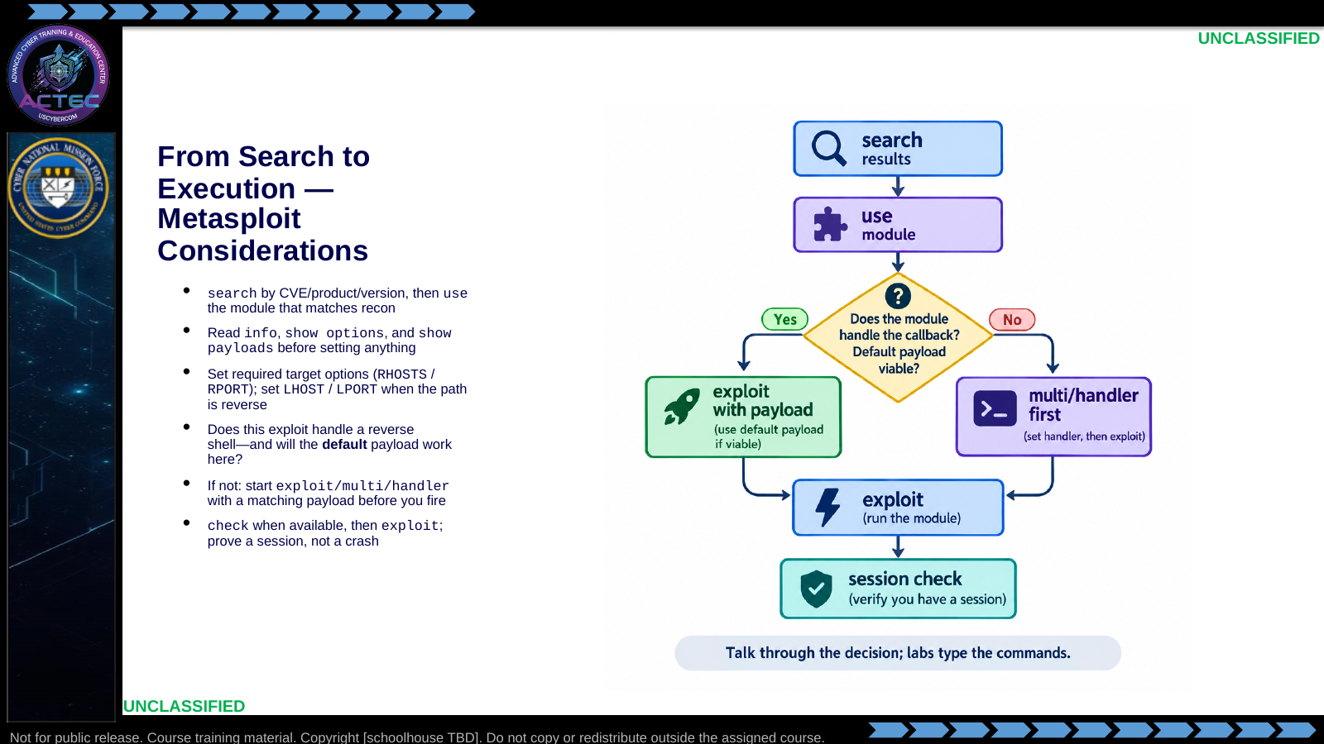  Slide 14: From Search to Execution — Metasploit Considerations  Duration: 2 min | Say: - "This is a conceptual walk of Metasploit employment—not a live demo. You have already seen msfconsole; Vulnhub and gaining-access labs are where you type."  - "Start from evidence: search by CVE, product, or version string from recon. Then use the module that actually fits—do not grab the first hit."  - "Before you set a single option, read the module. info tells you what it does and what it expects. show options lists required versus optional. show payloads lists what this exploit can actually deliver."  - "Target options first: RHOSTS and RPORT from the banner. If the path is reverse, LHOST must be an address the target can reach, and LPORT must be allowed outbound from their side."  - "Then the payload decision, which is the one operators skip. Does this exploit handle a reverse shell itself, or does it only trigger code with no built-in callback?"  - "If it does handle a reverse payload: will the default work on this OS, architecture, and egress? Defaults are convenience, not a promise. Staged reverse_tcp fails when the second connection cannot return. Wrong arch or a bind payload on a filtered port fails silently."  - "If the exploit does not handle the shell—or the default is wrong—do not fire yet. Stand up exploit/multi/handler with the same payload, LHOST, and LPORT you intend to use, then exploit. Mismatched handler and payload is a common no-session."  - "When check exists, run it. Then exploit. A crash, a 500, or a hanging job is not access. You need a session you can interact with."  - "Labs will make you type this. Here you own the questions you ask before exploit."  Show: - Trace search → use → options → the payload/handler diamond → exploit → session.  - Linger on the diamond: default payload versus a separate multi/handler.  Do: - Ask: "Name one reason the default reverse payload would fail even if the exploit itself is right."  - Accept: wrong LHOST, egress filter, staged second connect blocked, wrong arch, bind instead of reverse.  - Follow-up: "When would you start multi/handler before clicking exploit?" Drive toward: exploit does not include a working reverse payload, or you replaced the default and must match the listener.  Ask (Q): Name one reason the default reverse payload would fail even if the exploit itself is right.  Expected Response (A): exploit does not include a working reverse payload, or you replaced the default and must match the listener
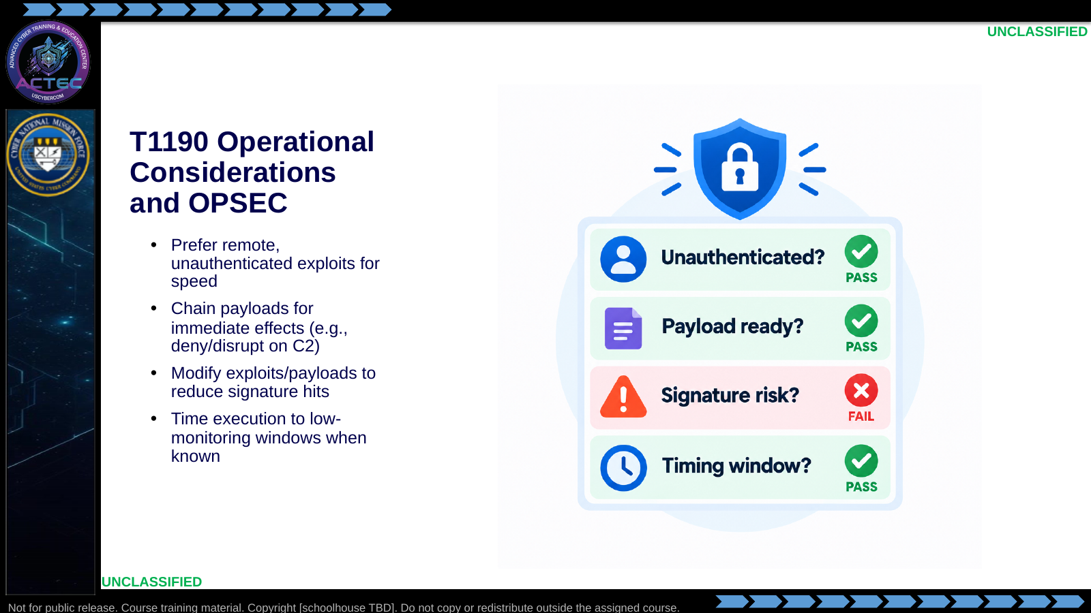  Slide 15: T1190 Operational Considerations and OPSEC  Duration: 2 min | Say: - "Speed favors remote unauthenticated paths."  - "Have the post-access action ready before you fire."  - "Stock payloads are loud; customize when the environment warrants it."  - "If hunt data shows quiet hours on their monitoring, use them."  - "Stability matters: a crash without a session can burn the path."  Show: - Tick through the checklist aloud.  Do: - Ask: "What do you prepare before clicking exploit?"  Ask (Q): What do you prepare before clicking exploit?  Expected Response (A): Facilitation. Use the Say/Do already on this row; do not force a single keyed answer.
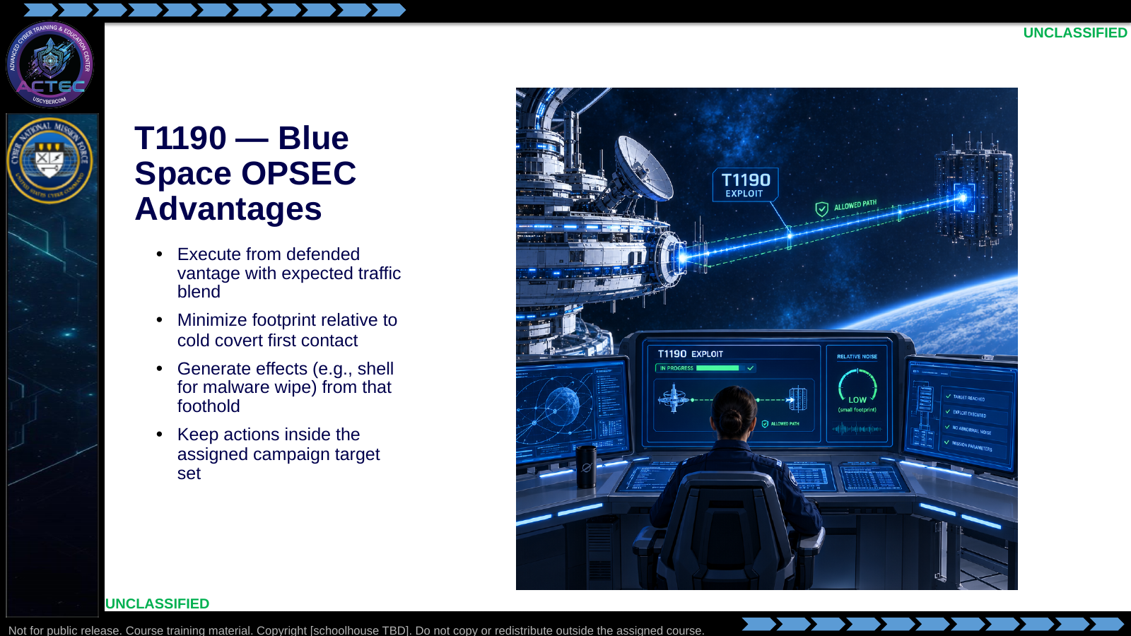  Slide 16: T1190 — Blue Space OPSEC Advantages  Duration: 2 min | Say: - "Blue space does not make exploits invisible."  - "It often makes them less anomalous than a brand-new covert source."  - "Use that to land the shell, then produce the planned effect."  - "Example effect path: shell → locate malware staging → wipe or deny it."  - "Stay inside assigned adversary targets."  Show: - Point to vantage, path, and effect sequence.  Do: - Transition: "Remote services are next—same discipline, different entry surface."  Ask (Q): What is the operational takeaway from this row?  Expected Response (A): Facilitation. Restate the Say/Do in operator terms. Do not invent a new teaching point.
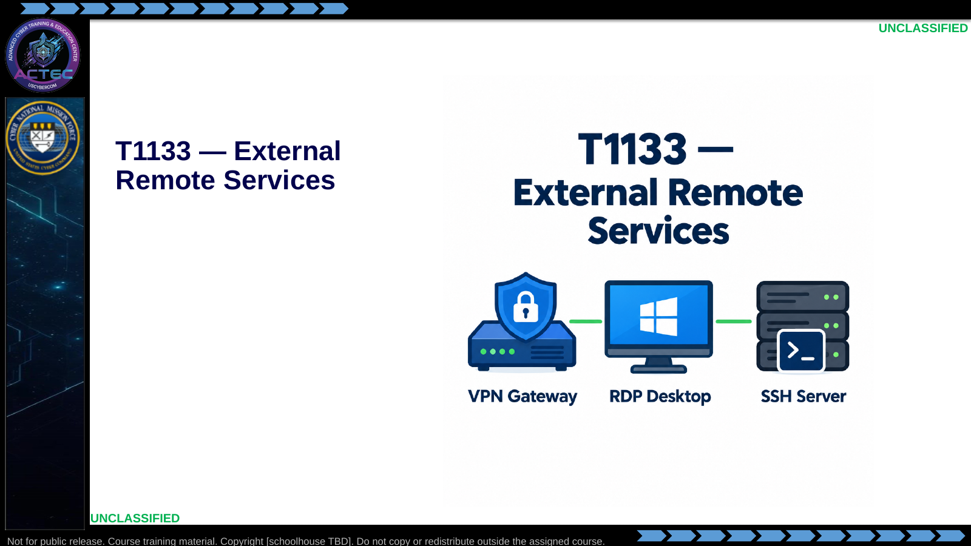  Slide 17: T1133 — External Remote Services  Duration: 2 min | Say: - "Second technique: external remote services."  - "The next slide applies this technique to exposed remote-access surfaces."  Show: - Hold on the technique title and icons, then advance.  Do: - None required beyond the transition.  Ask (Q): What is the operational takeaway from this row?  Expected Response (A): Facilitation. Restate the Say/Do in operator terms. Do not invent a new teaching point.
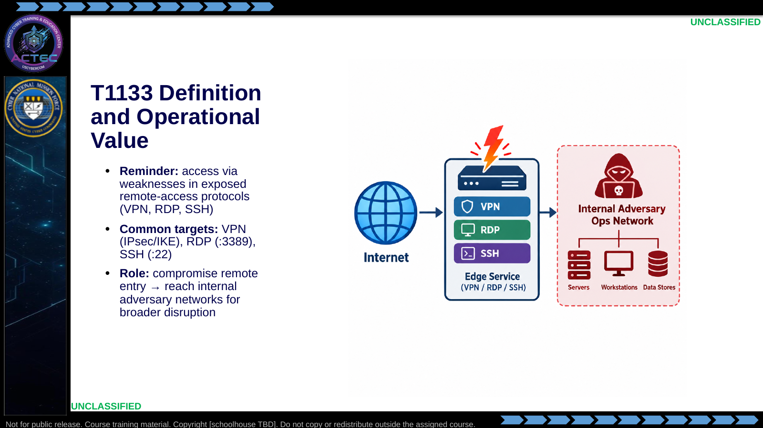  Slide 18: T1133 Definition and Operational Value  Duration: 2 min | Say: - "T1133 is about the remote-access plane."  - "VPN gateways, RDP hosts, SSH servers are primary surfaces."  - "Counterstrike value is depth: edge compromise unlocks interior effects."  - "Use the recon workflow to reveal the service and version, then verify applicability before selecting a module."  Show: - Trace internet → edge → internal.  Do: - Ask: "Why might SSH on an internal jump host matter more than a public marketing site?"  Ask (Q): Why might SSH on an internal jump host matter more than a public marketing site?  Expected Response (A): Facilitation. Use the Say/Do already on this row; do not force a single keyed answer.
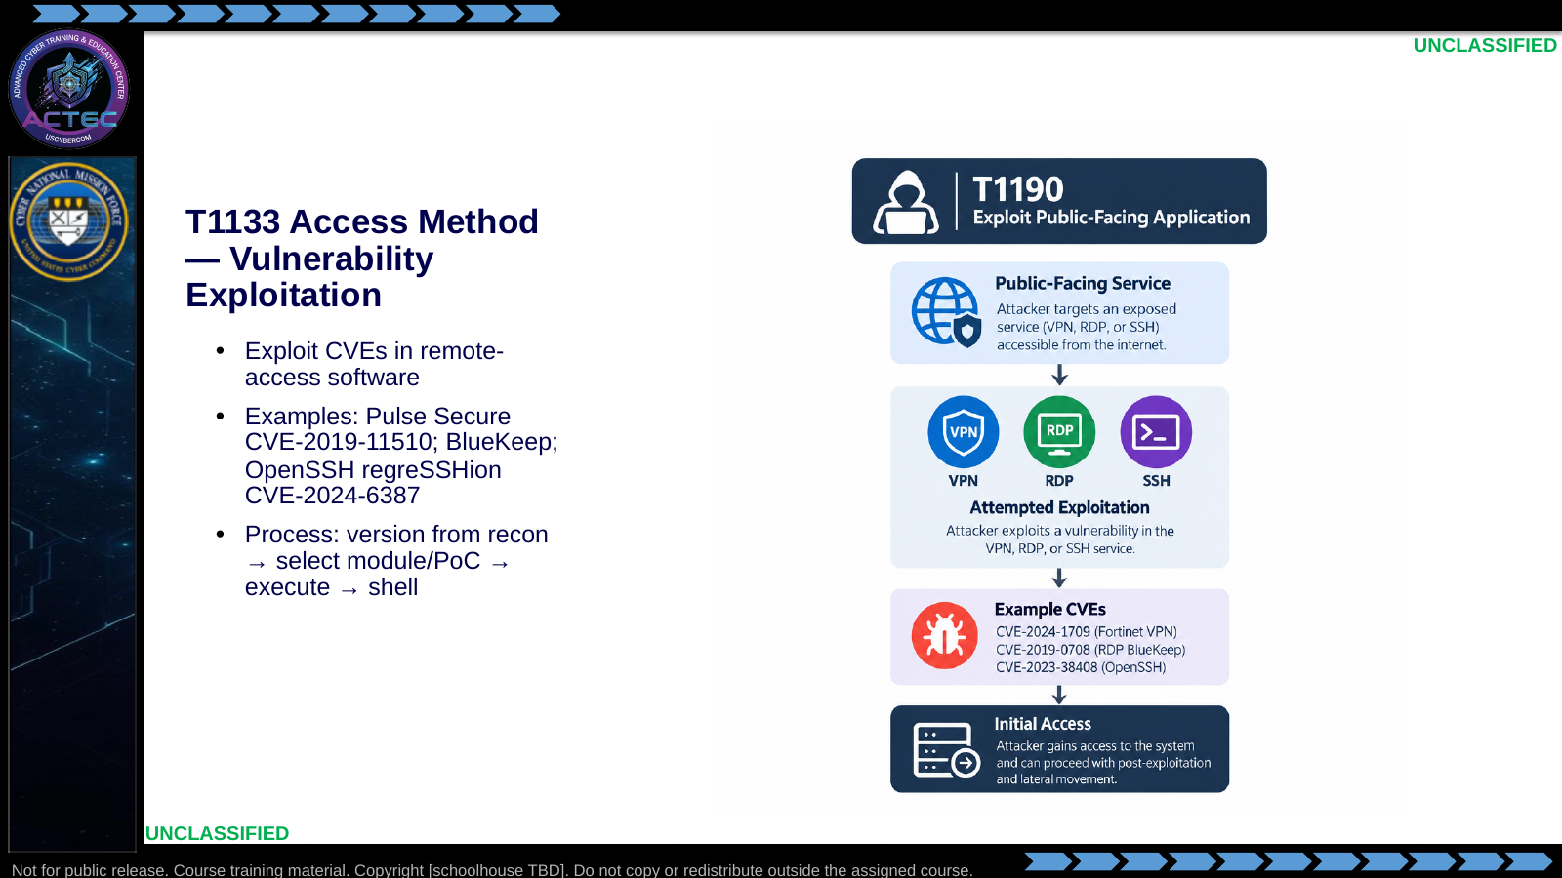  Slide 19: T1133 Access Method — Vulnerability Exploitation  Duration: 2 min | Say: - "Primary access method here is vulnerability exploitation."  - "Same discipline as T1190: version, match, prepare, execute."  - "Pulse Secure RCE, BlueKeep, and regreSSHion are teaching exemplars."  - "Metasploit modules exist for several of these; PoCs for others."  - "Do not skip version confirmation—remote service exploits are crash-prone."  Show: - Align this process strip with the earlier T1190 strip to show reuse.  Do: - Ask students where they would look up the CVE after seeing OpenSSH_7.4 in a banner.  Ask (Q): What is the operational takeaway from this row?  Expected Response (A): Facilitation. Restate the Say/Do in operator terms. Do not invent a new teaching point.
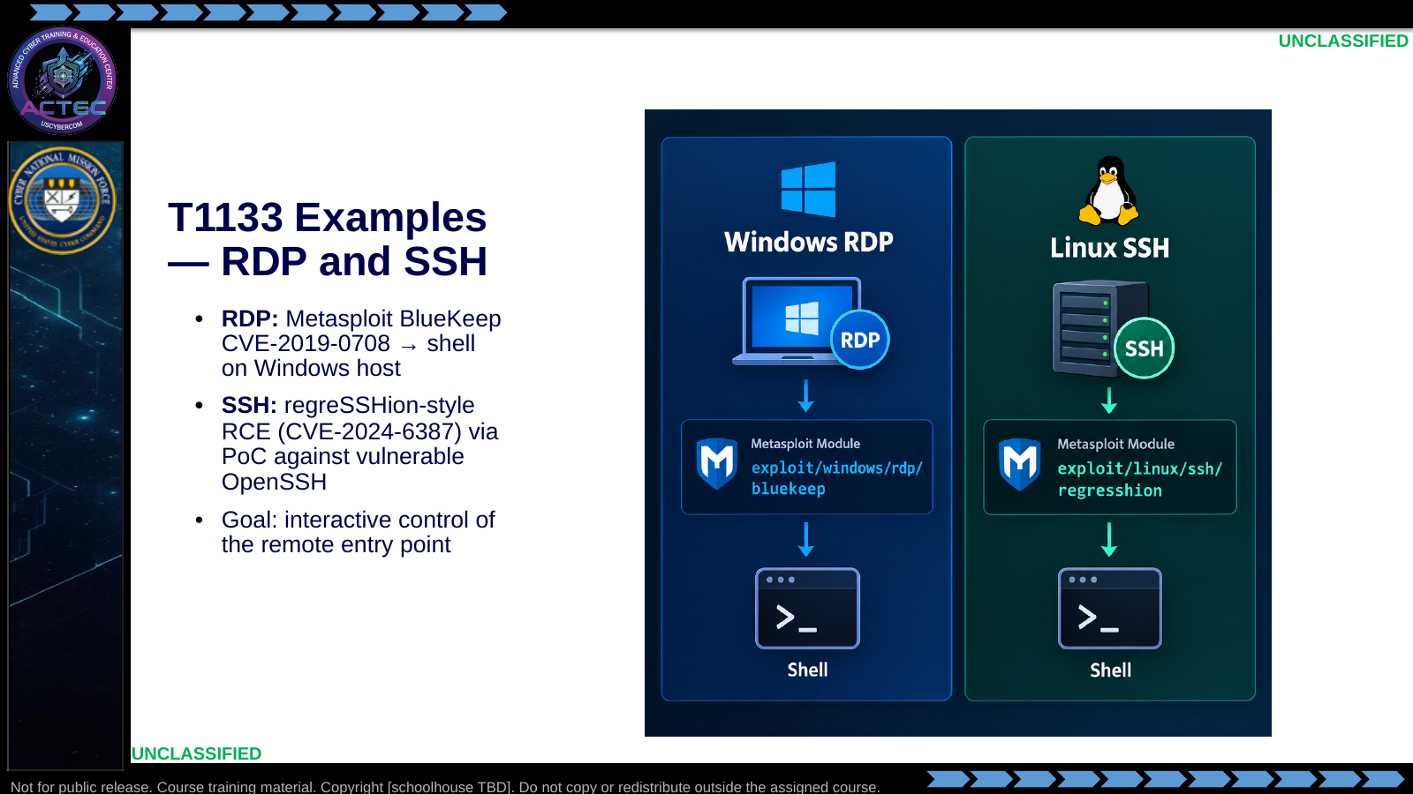  Slide 20: T1133 Examples — RDP and SSH  Duration: 2 min | Say: - "RDP example: BlueKeep module path when version and conditions match."  - "SSH example: modern RCE classes like regreSSHion when the OpenSSH build is vulnerable."  - "Both aim at a usable shell on the remote service host."  - "That host is often an ops console or jump box—high value for follow-on effects."  Show: - Compare the two cards.  Do: - Ask: "What recon artifact decides BlueKeep versus a credential spray instead?"  Ask (Q): What recon artifact decides BlueKeep versus a credential spray instead?  Expected Response (A): Facilitation. Use the Say/Do already on this row; do not force a single keyed answer.
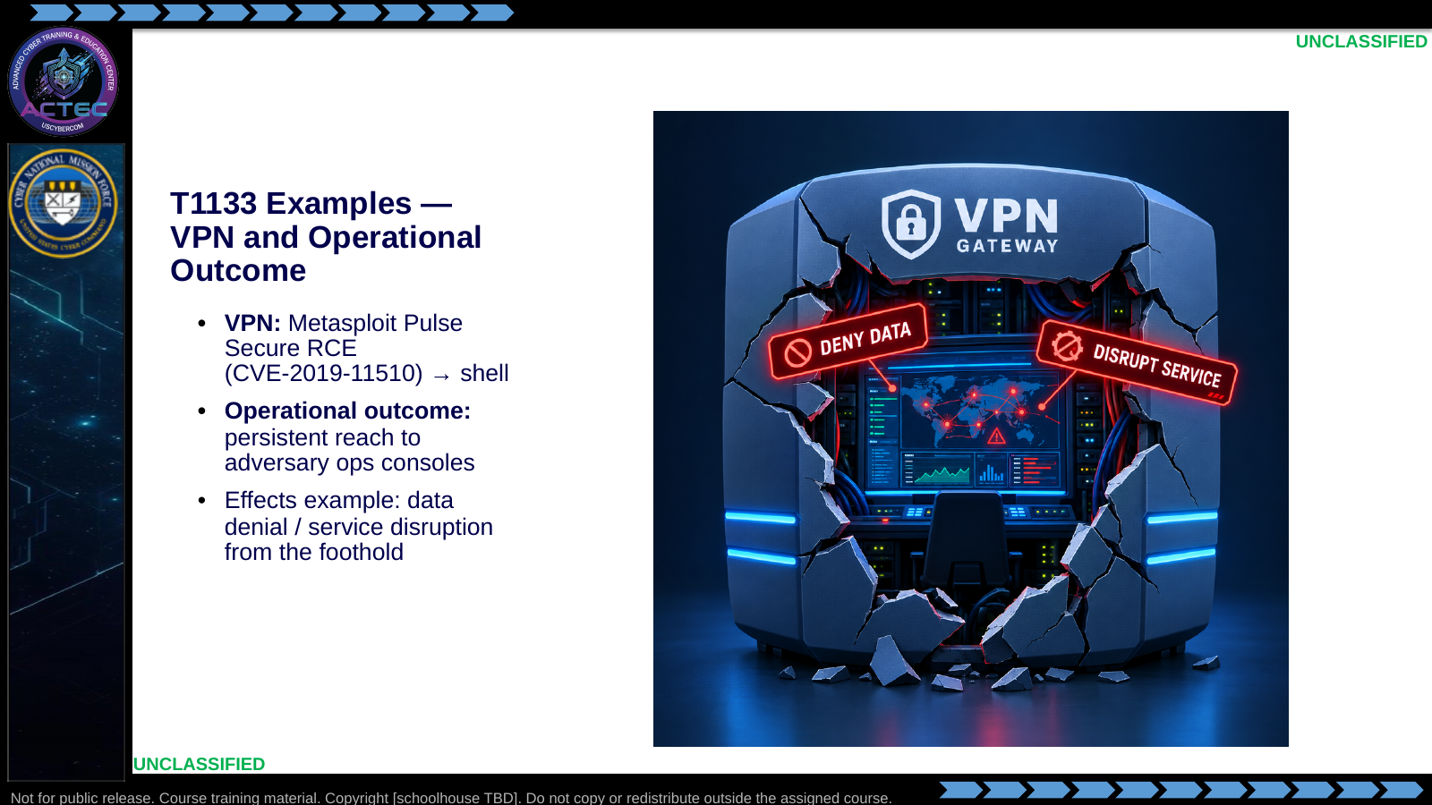  Slide 21: T1133 Examples — VPN and Operational Outcome  Duration: 2 min | Say: - "VPN gateways concentrate access."  - "Pulse Secure CVE-2019-11510 is the classic teaching exploit."  - "Landing there can mean durable reach into adversary operations."  - "From that console you stage denial or disruption effects."  - "Document the path—follow-on teams need the exact entry method."  Show: - Trace gateway → console → effect.  Do: - Ask what you would record for handoff after a VPN shell lands.  Ask (Q): What is the operational takeaway from this row?  Expected Response (A): Facilitation. Restate the Say/Do in operator terms. Do not invent a new teaching point.
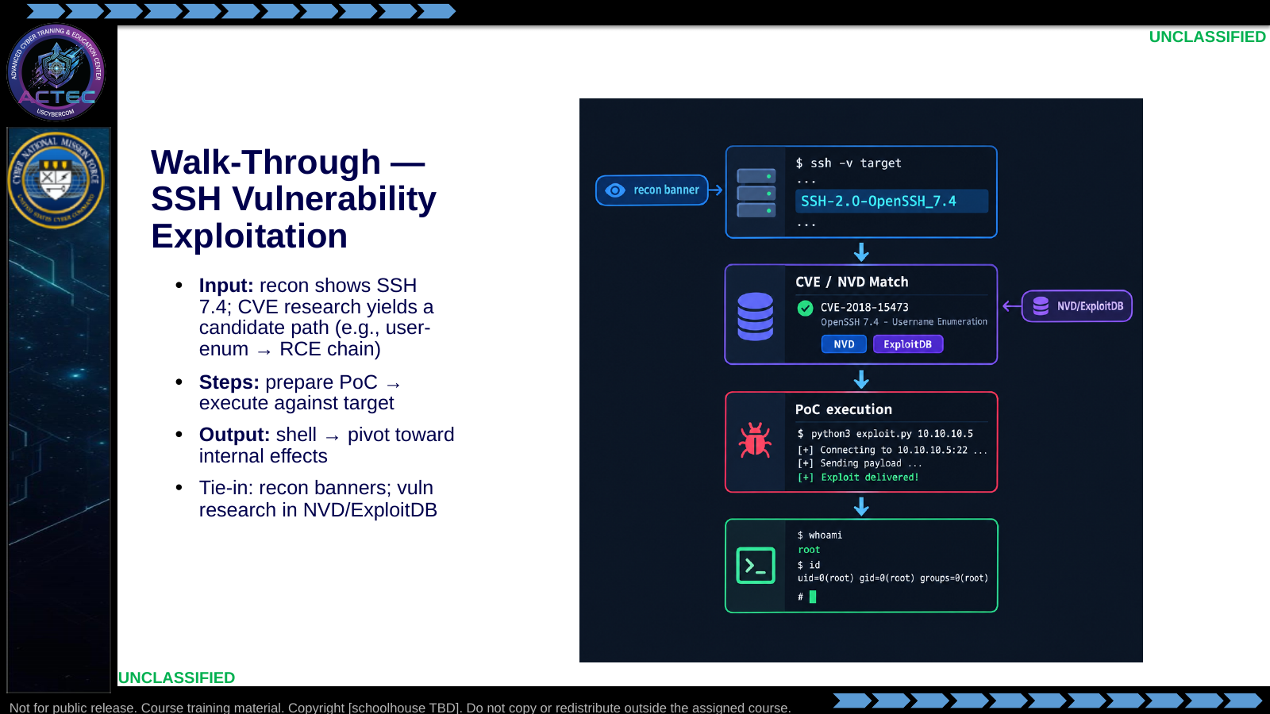  Slide 22: Walk-Through — SSH Vulnerability Exploitation  Duration: 2 min | Say: - "Purpose: walk T1133 execution without requiring a full live demo."  - "Input comes from recon—service and version."  - "Vulnerability search follows NVD, ExploitDB, and module fit."  - "Use those sources to form and narrow a candidate; verify the advisory and target conditions before treating it as applicable."  - "Narrate prepare and execute; if no live target, show expected shell output."  - "Blue-space paths keep this lower risk than a cold covert launch."  - "Debrief: interpretation matters—version evidence can narrow the path, but it does not establish exploitability alone."  - "Transition next to operational checks for T1133."  Show: - Point to each walk-through panel in order.  - If simulating, display a short expected shell snippet.  Do: - Ask: "What would you refuse to execute if the version match was ambiguous?"  - Collect one refusal criterion (wrong major version, untested crash risk, etc.).  Ask (Q): What would you refuse to execute if the version match was ambiguous?  Expected Response (A): Facilitation. Use the Say/Do already on this row; do not force a single keyed answer.
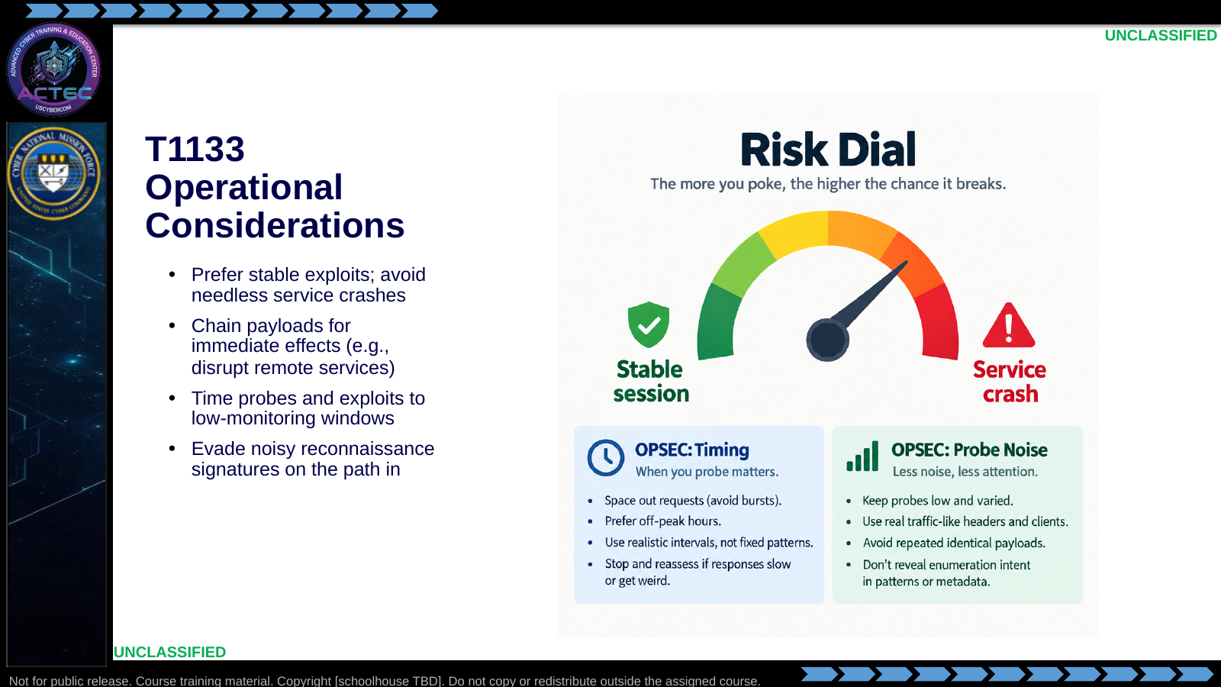  Slide 23: T1133 Operational Considerations  Duration: 2 min | Say: - "Remote service exploits can brick the door you need."  - "Choose stability when the mission needs the service alive under your control."  - "Still prepare the effect payload so you do not waste the window."  - "Throttle and time probes—banner grabbing can be as loud as the exploit."  - "Evasion on the path in protects the technique for reuse."  Show: - Move the risk dial toward "Stable session."  Do: - Ask when crashing the service might still be acceptable (rare; only if effect requires denial and access is already redundant).  Ask (Q): What is the operational takeaway from this row?  Expected Response (A): Facilitation. Restate the Say/Do in operator terms. Do not invent a new teaching point.
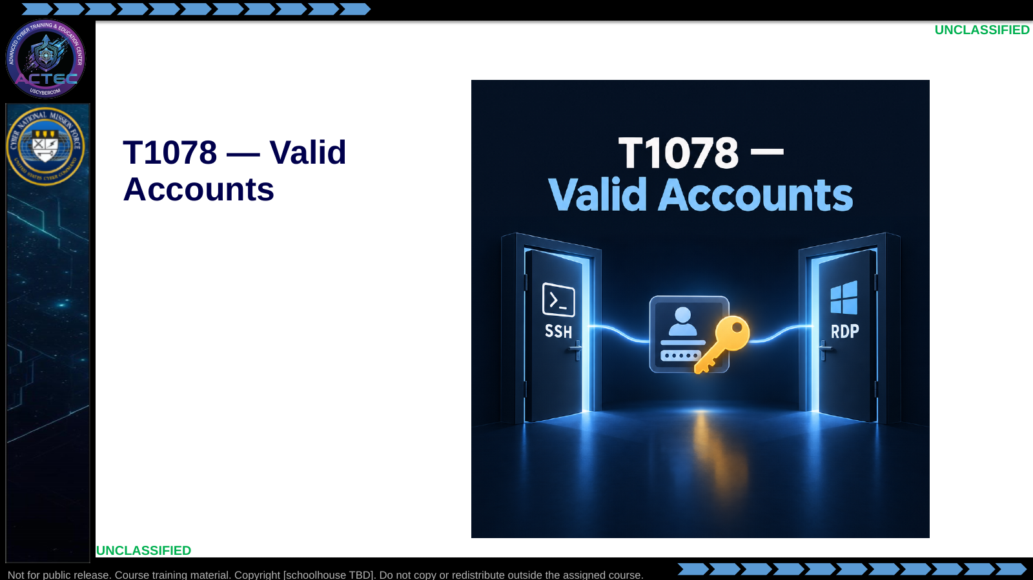  Slide 24: T1078 — Valid Accounts  Duration: 2 min | Say: - "Third technique: valid accounts."  - "The next slide covers the evidence sources and operational value."  Show: - Hold on the technique title and credential icon, then advance.  Do: - None required beyond the transition.  Ask (Q): What is the operational takeaway from this row?  Expected Response (A): Facilitation. Restate the Say/Do in operator terms. Do not invent a new teaching point.
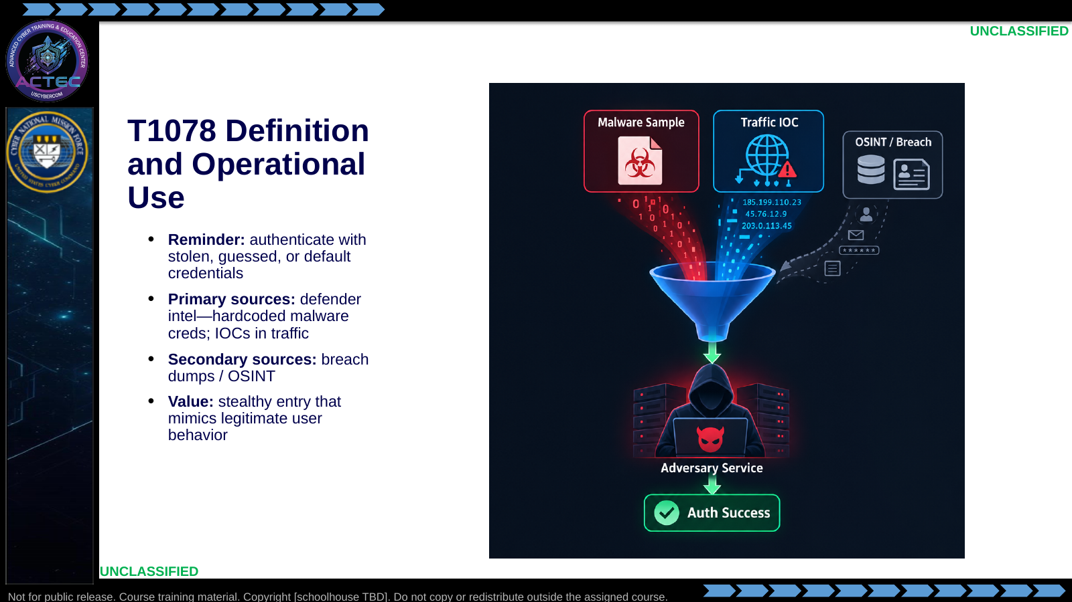  Slide 25: T1078 Definition and Operational Use  Duration: 2 min | Say: - "Valid means the system accepts the login."  - "Primary gold: credentials pulled from malware and live traffic in blue space."  - "Secondary: breach corpuses and OSINT when they map to the same actor infrastructure."  - "Operationally, successful auth looks like a normal user—ideal for persistence and quiet effects."  Show: - Emphasize primary over secondary sources.  Do: - Ask why primary defender intel usually beats generic breach lists for counterstrike.  Ask (Q): What is the operational takeaway from this row?  Expected Response (A): Facilitation. Restate the Say/Do in operator terms. Do not invent a new teaching point.
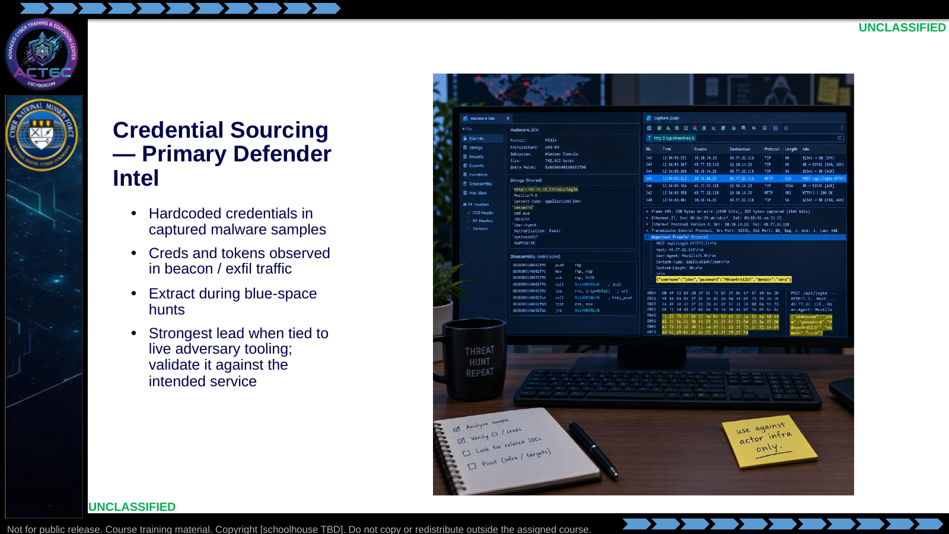  Slide 26: Credential Sourcing — Primary Defender Intel  Duration: 2 min | Say: - "Start with what the adversary already sent you."  - "Malware samples often embed SSH/RDP/panel passwords."  - "Beacon and exfil channels leak auth material."  - "A connection between the tooling and target makes the credential a stronger lead, not proof of access."  - "Validate the cred against the intended service before claiming access."  Show: - Point to sample analysis and PCAP highlight.  Do: - Ask for one safe validation step before spraying a harvested password widely.  Ask (Q): What is the operational takeaway from this row?  Expected Response (A): Facilitation. Restate the Say/Do in operator terms. Do not invent a new teaching point.
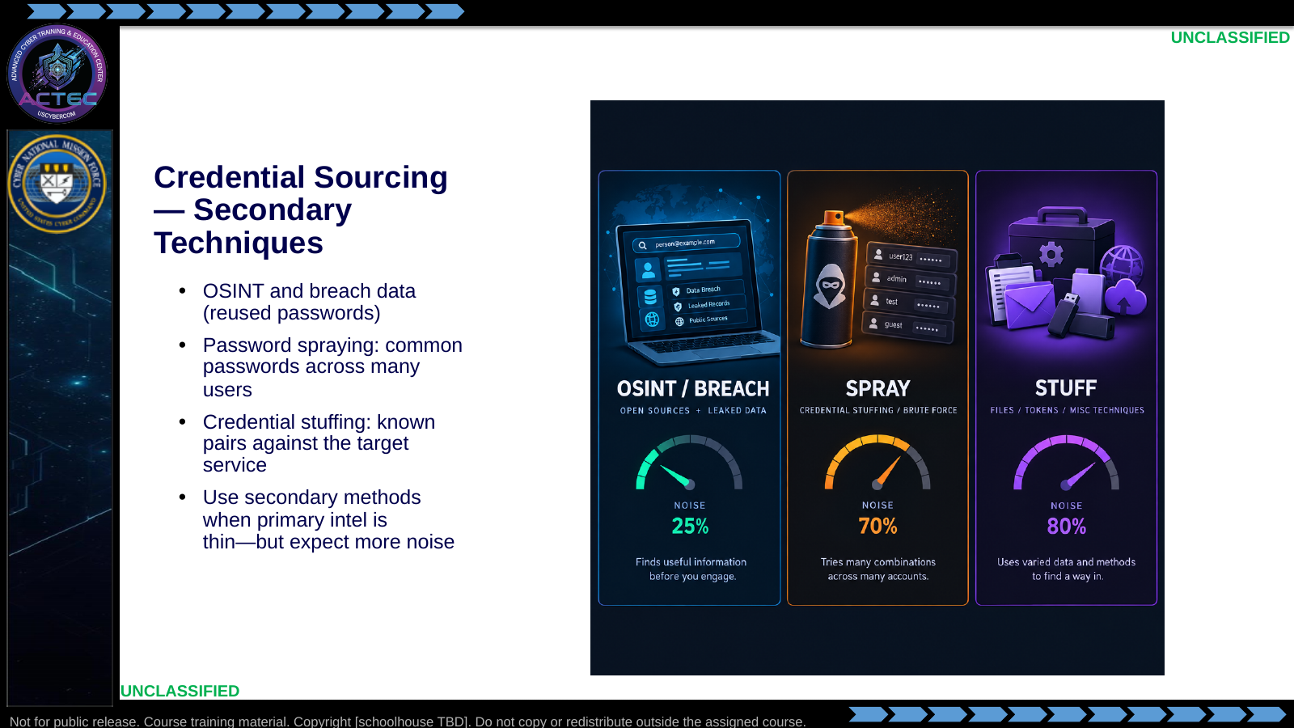  Slide 27: Credential Sourcing — Secondary Techniques  Duration: 2 min | Say: - "Secondary methods fill gaps."  - "Breach reuse works when actors recycle passwords."  - "Spraying tries common passwords across a user list."  - "Stuffing replays known pairs at the service."  - "These are louder and lockout-prone—throttle and watch responses."  Show: - Compare noise meters across tiles.  Do: - Ask which secondary method fits a short user list with malware-derived password candidates.  Ask (Q): What is the operational takeaway from this row?  Expected Response (A): Facilitation. Restate the Say/Do in operator terms. Do not invent a new teaching point.
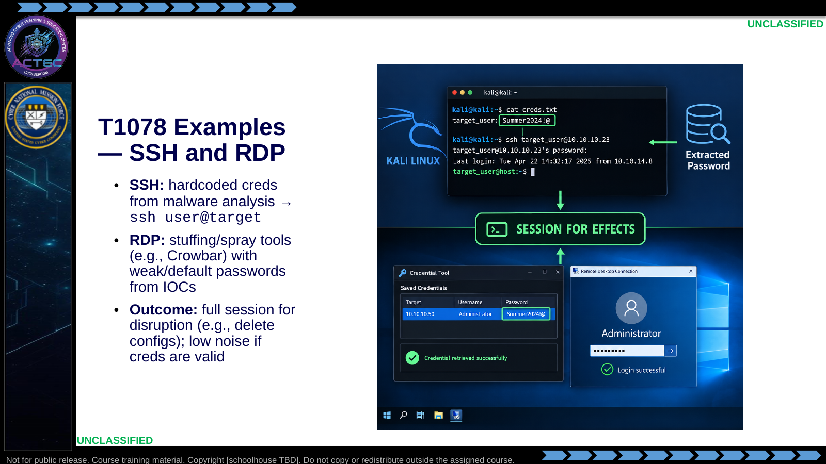  Slide 28: T1078 Examples — SSH and RDP  Duration: 2 min | Say: - "SSH with malware-hardcoded admin creds is a common win."  - "RDP with weak or default passwords from IOCs is the Windows counterpart."  - "Tools like Crowbar appear in stuffing/spray workflows—understand lockout risk."  - "Valid creds mean the session looks legitimate—use that for deliberate effects, not thrashing."  Show: - Contrast SSH and RDP success paths.  Do: - Ask what effect they would run first on a quiet valid-account session.  Ask (Q): What is the operational takeaway from this row?  Expected Response (A): Facilitation. Restate the Say/Do in operator terms. Do not invent a new teaching point.
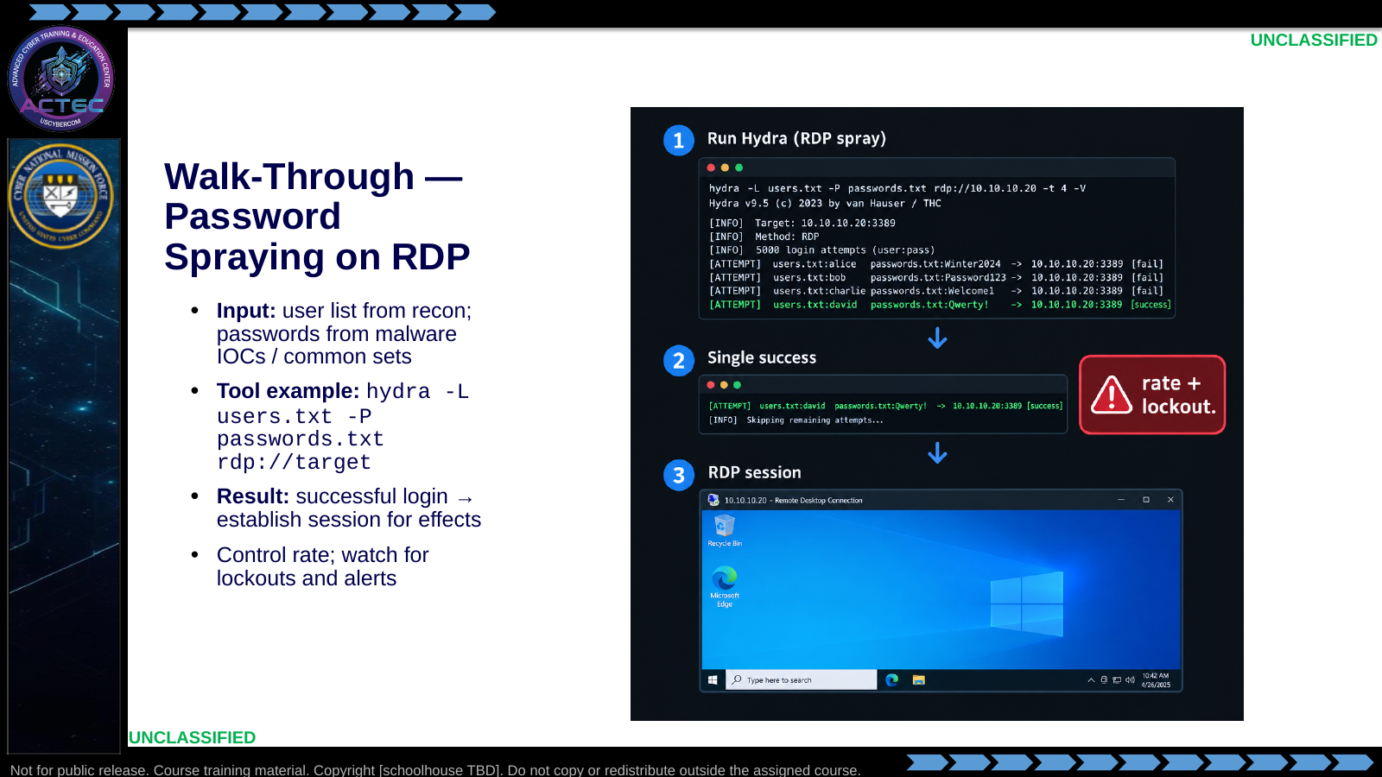  Slide 29: Walk-Through — Password Spraying on RDP  Duration: 2 min | Say: - "Walk-through intent: show a controlled spray, not a brute-force flood."  - "Users come from recon; passwords prefer malware IOC lists first."  - "Hydra is a teaching example—any disciplined sprayer follows the same logic."  - "One valid login is enough; stop and document."  - "Then establish the interactive session and move to effects."  Show: - Narrate the command options: -L user list, -P password list, rdp:// target.  - Highlight the success line.  Do: - Ask: "What evidence tells you to stop spraying immediately?"  Ask (Q): What evidence tells you to stop spraying immediately?  Expected Response (A): Facilitation. Use the Say/Do already on this row; do not force a single keyed answer.
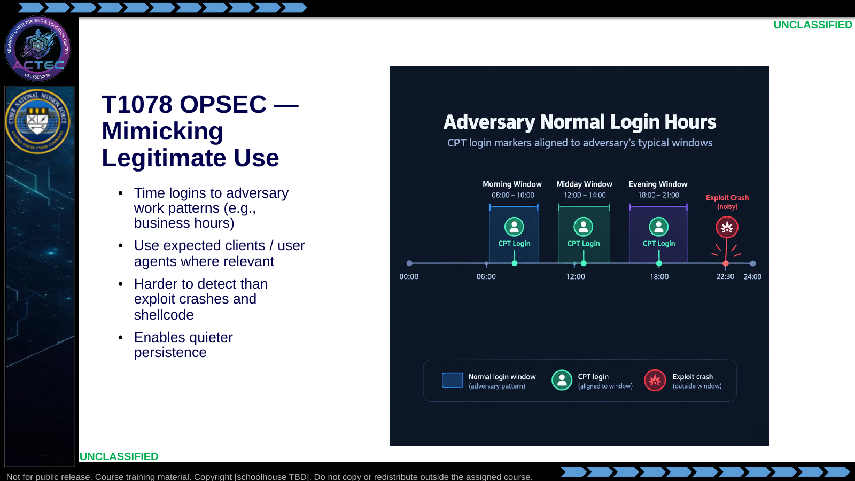  Slide 30: T1078 OPSEC — Mimicking Legitimate Use  Duration: 2 min | Say: - "Valid-account OPSEC is behavioral."  - "Log in when they log in."  - "Use tools and clients that look native to that service."  - "You avoid the crash and payload signatures that betray exploits."  - "That quietness supports longer-lived access for phased effects."  Show: - Align CPT markers to the normal-hours band.  Do: - Transition: "Last technique flips their collection—internal spear phishing / lures."  Ask (Q): What is the operational takeaway from this row?  Expected Response (A): Facilitation. Restate the Say/Do in operator terms. Do not invent a new teaching point.
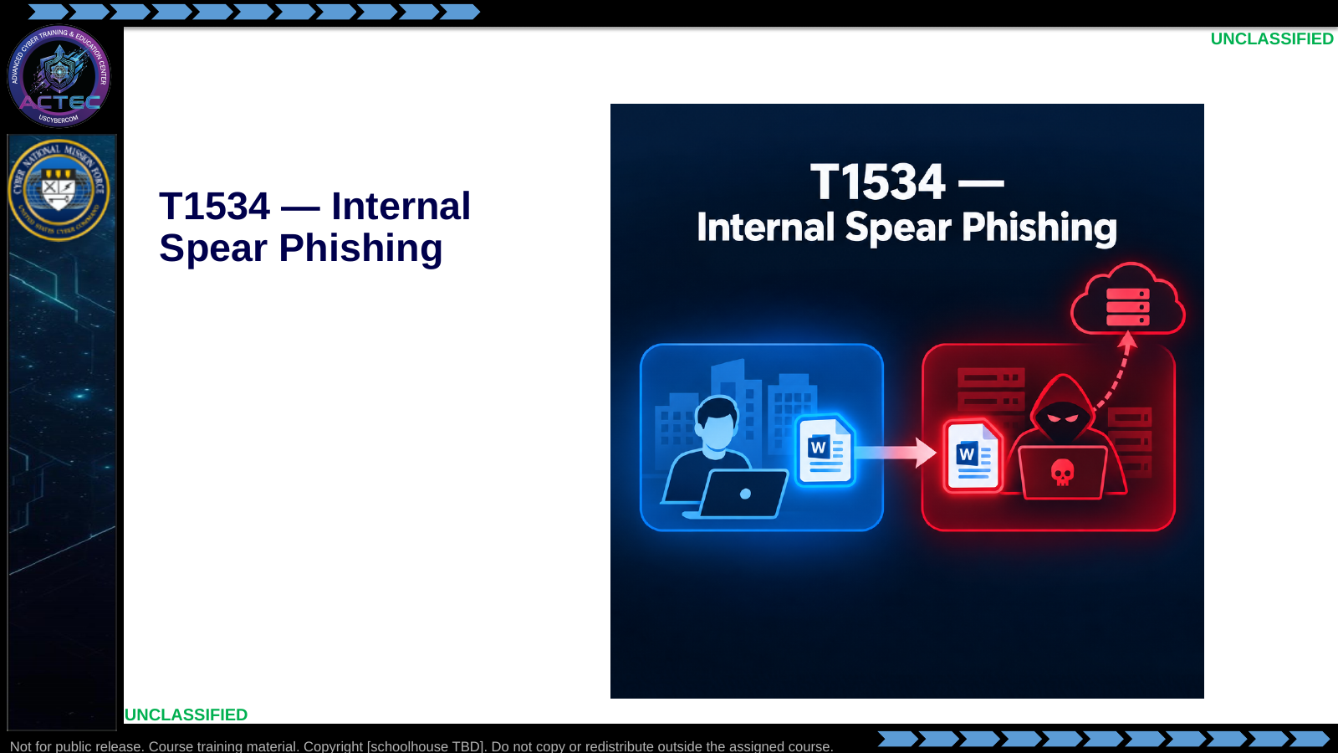  Slide 31: T1534 — Internal Spear Phishing  Duration: 2 min | Say: - "Fourth technique: internal spear phishing in the hunt/counterstrike sense."  - "The next slide explains the observed collection behavior that makes a lure relevant."  Show: - Hold on the technique title and image, then advance.  Do: - None required beyond the transition.  Ask (Q): What is the operational takeaway from this row?  Expected Response (A): Facilitation. Restate the Say/Do in operator terms. Do not invent a new teaching point.
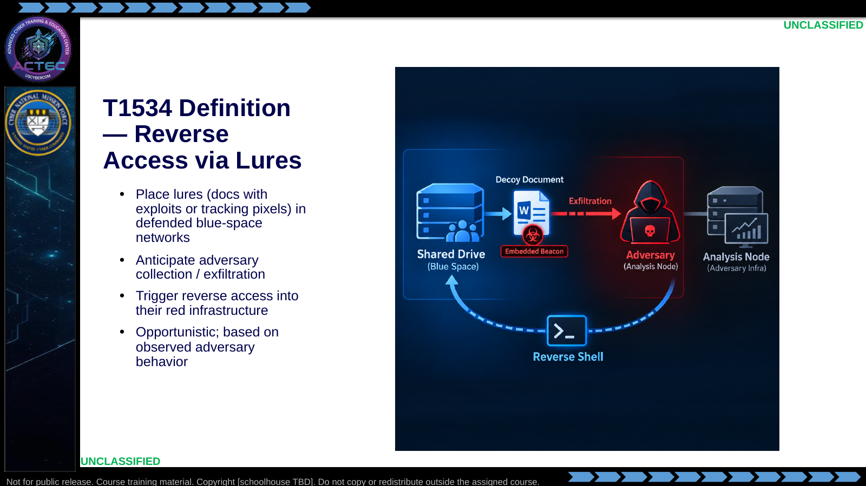  Slide 32: T1534 Definition — Reverse Access via Lures  Duration: 2 min | Say: - "This is unique to hunt-team counterstrike posture."  - "Lures live in blue space—email traps, shares, honey files."  - "When they steal and process the lure, the payload fires from their side."  - "You gain a foothold on their analysis or C2-adjacent host."  - "It is opportunistic: no observed collection pattern, no reliable T1534."  Show: - Walk plant → steal → process → reverse shell.  Do: - Ask what hunt evidence would justify seeding a lure tomorrow.  Ask (Q): What is the operational takeaway from this row?  Expected Response (A): Facilitation. Restate the Say/Do in operator terms. Do not invent a new teaching point.
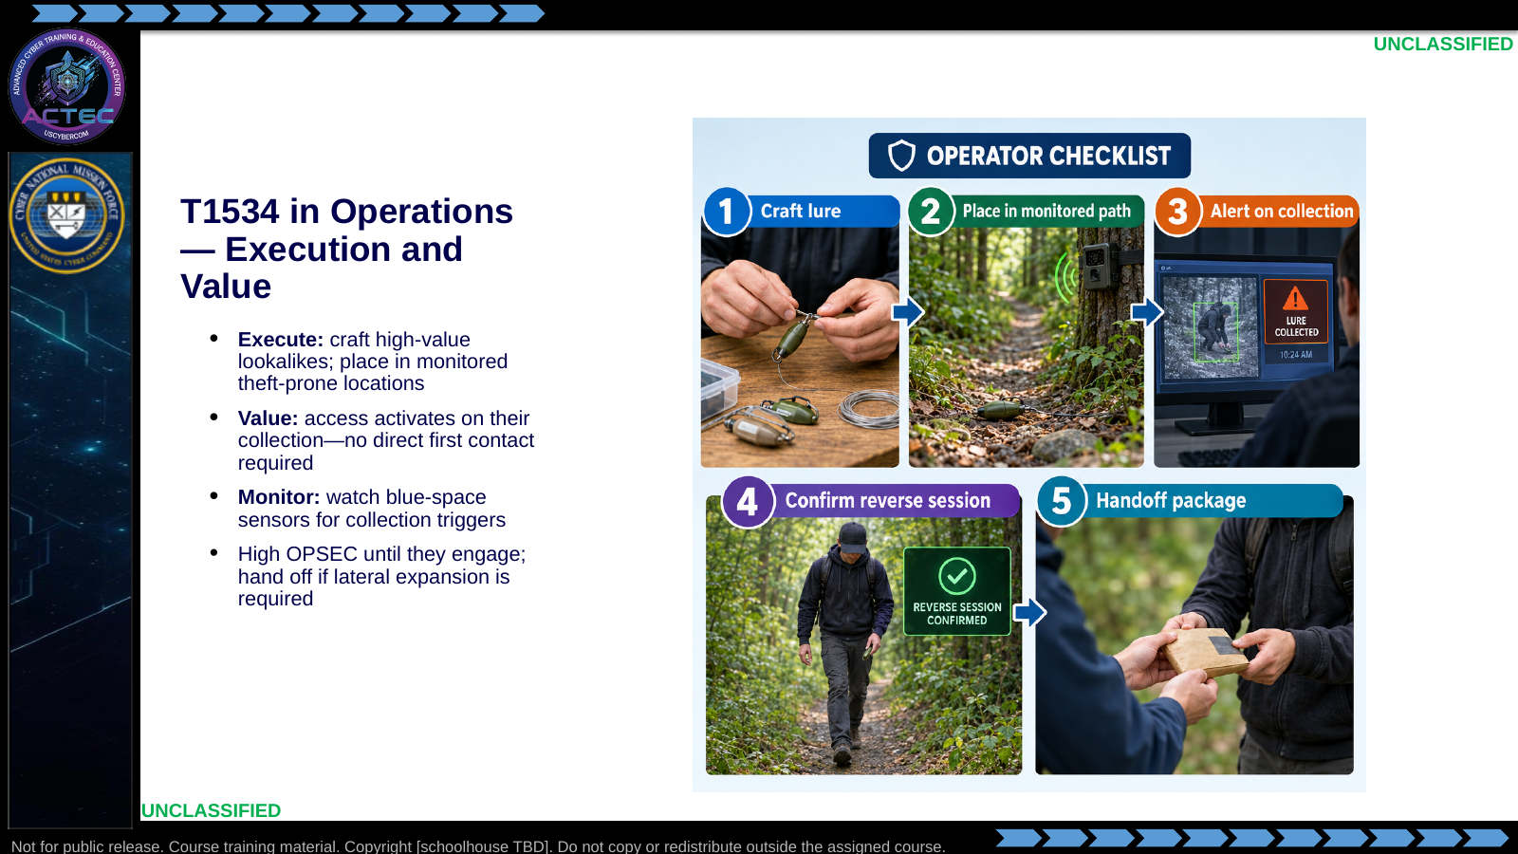  Slide 33: T1534 in Operations — Execution and Value  Duration: 2 min | Say: - "Craft lures that match what they already steal—fake intel docs, configs, keys."  - "Placement matters: put them on paths your sensors watch."  - "Value: they initiate contact by stealing."  - "You monitor for the trigger, then validate the reverse session."  - "If the mission needs deep lateral movement, package the foothold for follow-on / CMT transition."  Show: - Tick the checklist.  Do: - Ask what "success" looks like before anyone touches a keyboard on the red host.  Ask (Q): What is the operational takeaway from this row?  Expected Response (A): Facilitation. Restate the Say/Do in operator terms. Do not invent a new teaching point.
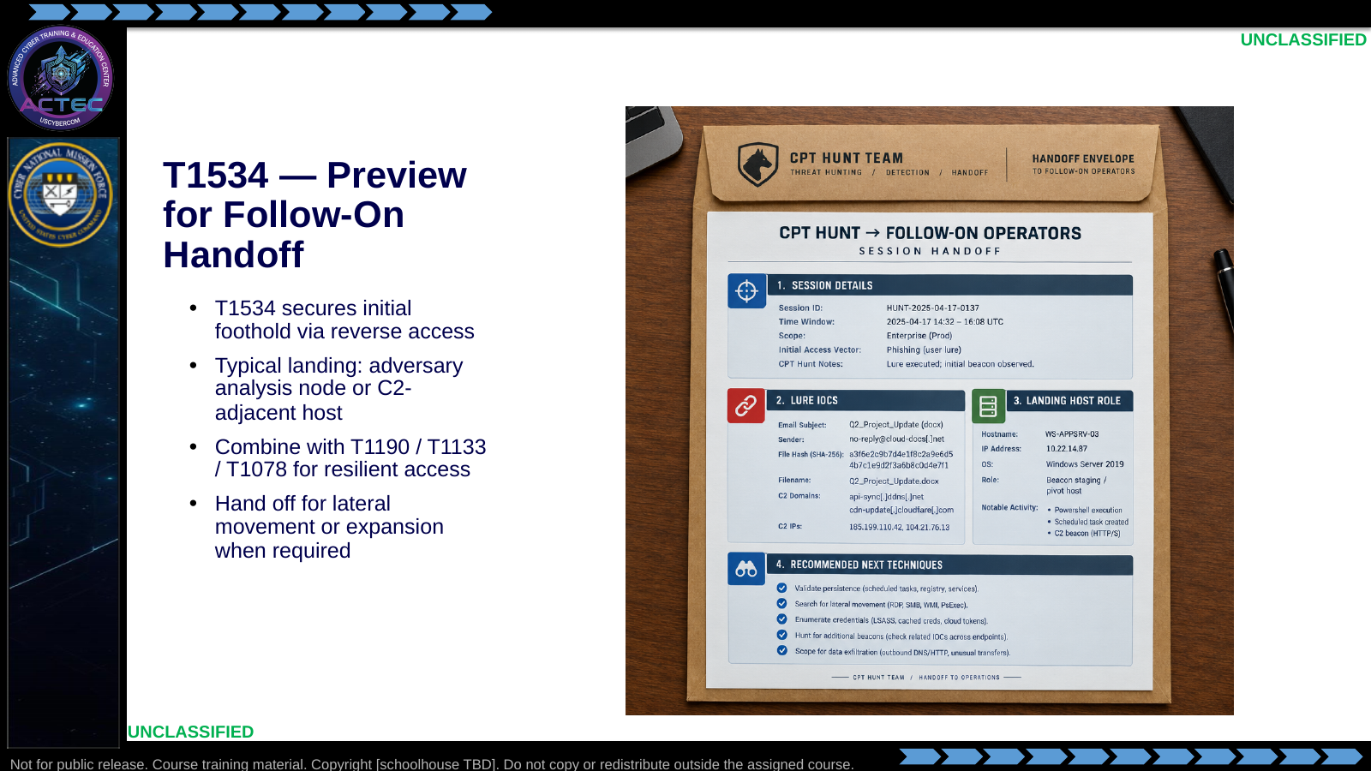  Slide 34: T1534 — Preview for Follow-On Handoff  Duration: 2 min | Say: - "Treat T1534 as a door opener."  - "You may land on an analysis box rather than the final objective host."  - "Keep other vectors warm so one patch does not end the mission."  - "When scope requires lateral movement beyond the foothold, hand off cleanly."  - "Handoff quality is part of the technique's success."  Show: - Point to each field in the handoff envelope.  Do: - Ask students to name three fields they would include in that envelope.  Ask (Q): What is the operational takeaway from this row?  Expected Response (A): Facilitation. Restate the Say/Do in operator terms. Do not invent a new teaching point.
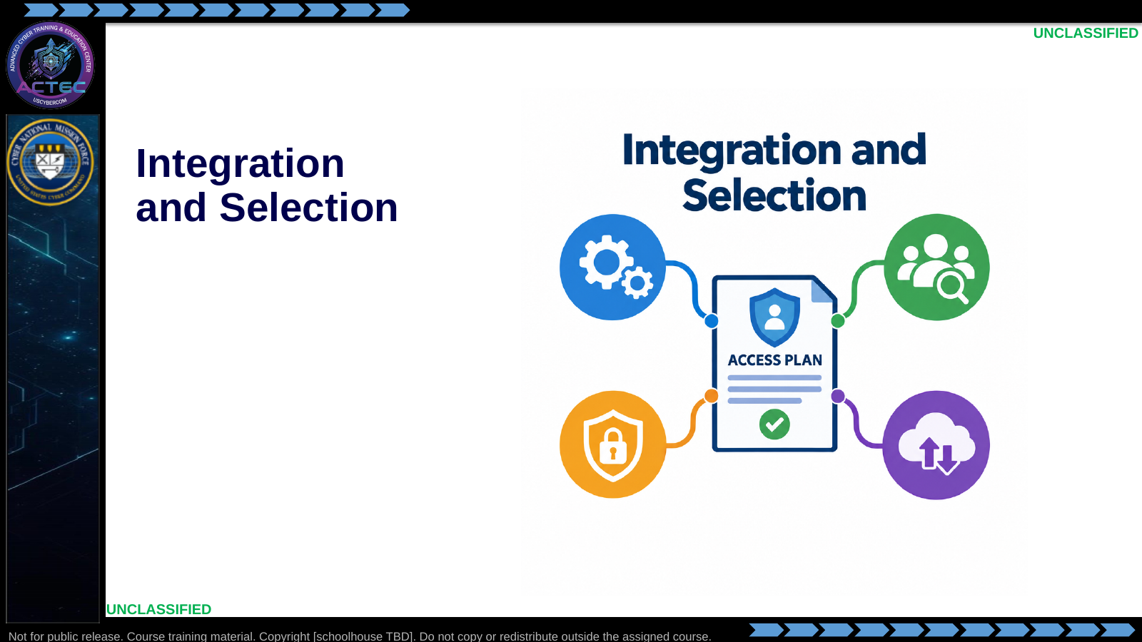  Slide 35: Integration and Selection  Duration: 2 min | Say: - "Last block: put the techniques to work together."  - "The next slides provide decision aids for selection, resilience, and handoff."  Show: - Hold on the technique icons and plan document, then advance.  Do: - None required beyond the transition.  Ask (Q): What is the operational takeaway from this row?  Expected Response (A): Facilitation. Restate the Say/Do in operator terms. Do not invent a new teaching point.
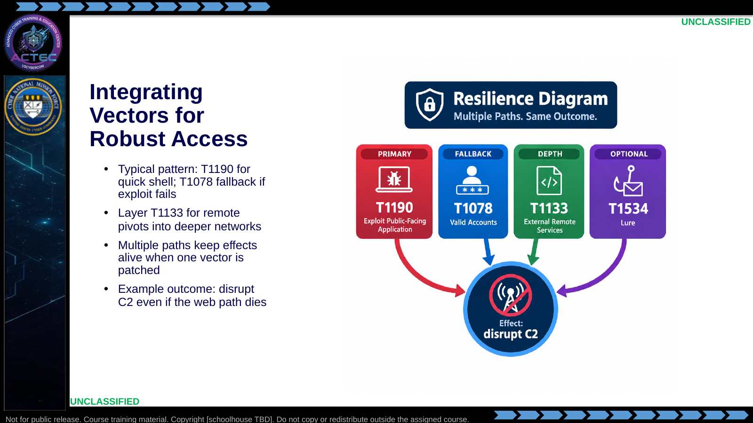  Slide 36: Integrating Vectors for Robust Access  Duration: 2 min | Say: - "Plan primary and fallback before you execute."  - "Exploits are fast; credentials are quiet insurance."  - "Remote-service paths add depth when the edge web tier is hardened."  - "Lures add an asynchronous path when they keep stealing."  - "Resilience means the effect still happens after a patch."  Show: - Trace each path to the shared effect.  Do: - Scenario: "Web CVE patched overnight—what is your morning path?"  Ask (Q): What is the operational takeaway from this row?  Expected Response (A): Facilitation. Restate the Say/Do in operator terms. Do not invent a new teaching point.
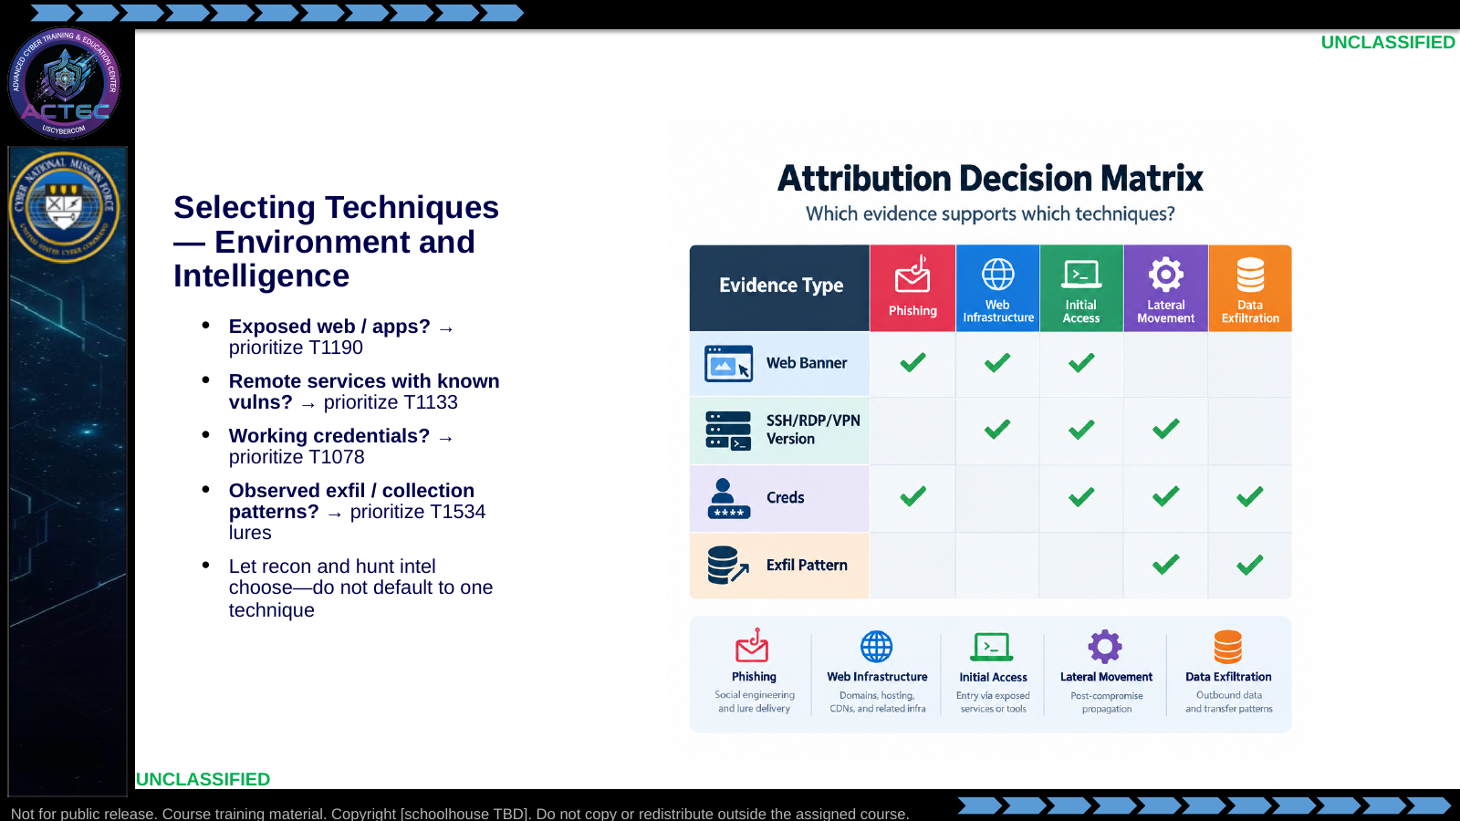  Slide 37: Selecting Techniques — Environment and Intelligence  Duration: 2 min | Say: - "Selection is evidence-driven."  - "Public app surface points to T1190."  - "Vulnerable remote services point to T1133."  - "Creds in hand point to T1078."  - "Active theft from blue space points to T1534."  - "If two are green, pick primary by mission tempo and keep the other as backup."  Show: - Fill checkmarks on the matrix with the class.  Do: - Give a one-minute recon vignette; students vote primary technique.  Ask (Q): What is the operational takeaway from this row?  Expected Response (A): Facilitation. Restate the Say/Do in operator terms. Do not invent a new teaching point.
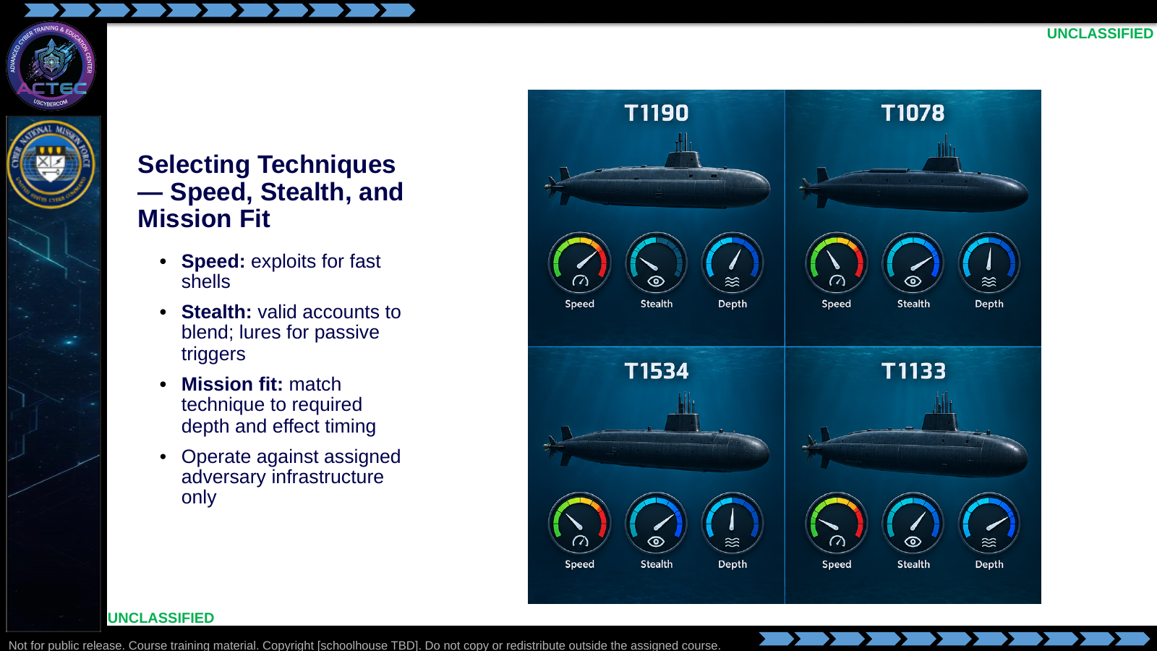  Slide 38: Selecting Techniques — Speed, Stealth, and Mission Fit  Duration: 2 min | Say: - "Requirements finish the selection."  - "Need a shell in minutes? Lead with a matched exploit."  - "Need to blend for days? Lead with valid accounts."  - "Need them to pull access to you? Seed the lure."  - "Need interior reach? Weight remote-service paths."  - "Stay on assigned adversary targets—scope is an execution constraint, not a debate topic."  Show: - Adjust the dials per technique.  Do: - Ask pairs to justify a primary technique using speed vs stealth for a "disrupt C2 before next beacon" mission.  Ask (Q): What is the operational takeaway from this row?  Expected Response (A): Facilitation. Restate the Say/Do in operator terms. Do not invent a new teaching point.
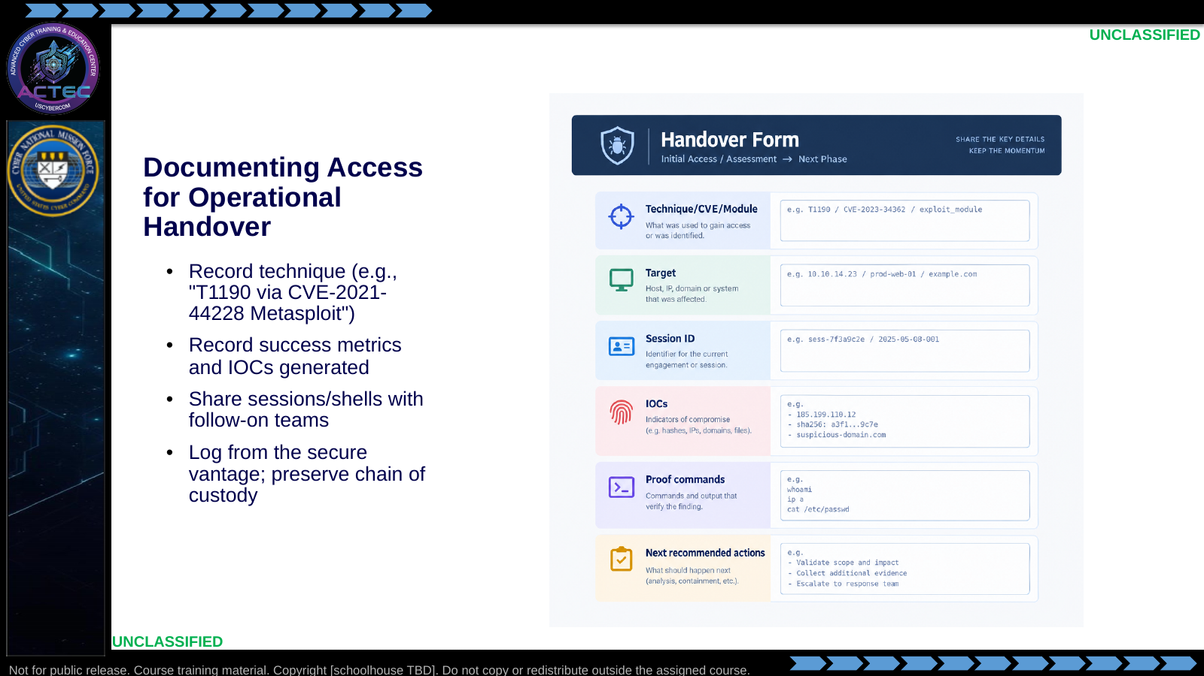  Slide 39: Documenting Access for Operational Handover  Duration: 2 min | Say: - "If it is not documented, the team cannot reuse it."  - "Name the technique and the exact module or PoC."  - "Capture proof: host, user, time, how you verified the session."  - "List IOCs you created so defenders and partners are not surprised."  - "Hand the live session cleanly—credentials, listener details, stability notes."  - "Logging from blue space supports custody and after-action review."  Show: - Walk each form field.  Do: - Students draft a five-line handoff for a fictional successful T1190.  Ask (Q): What is the operational takeaway from this row?  Expected Response (A): Facilitation. Restate the Say/Do in operator terms. Do not invent a new teaching point.
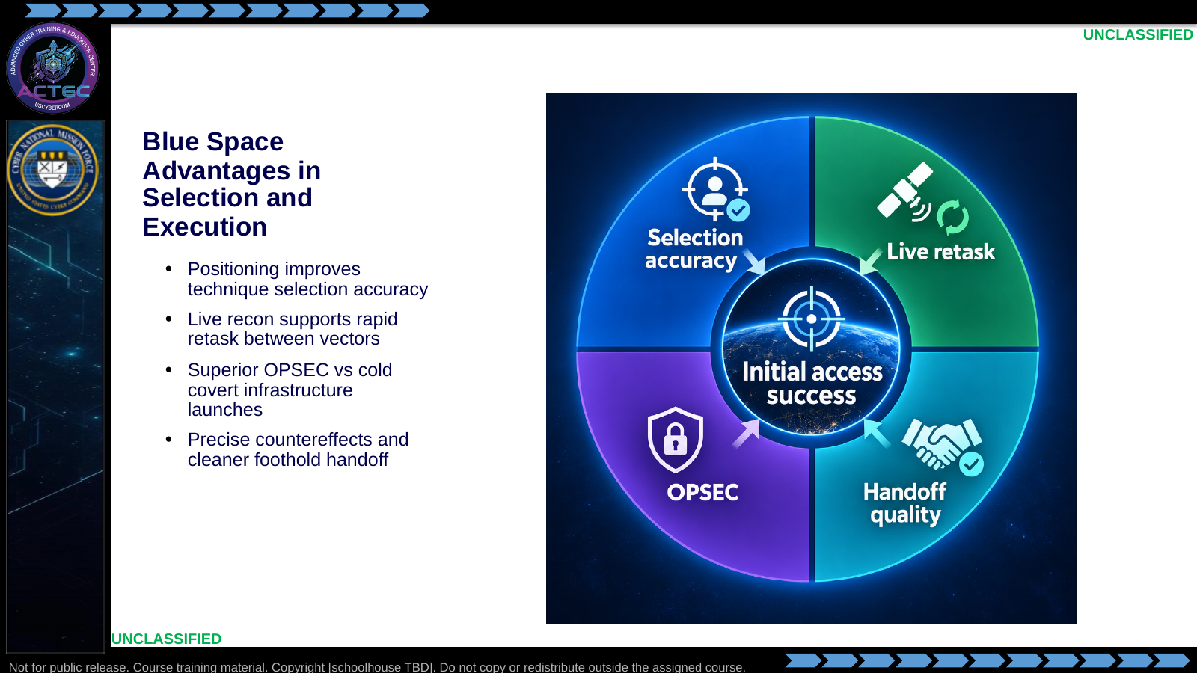  Slide 40: Blue Space Advantages in Selection and Execution  Duration: 2 min | Say: - "Return to positioning."  - "Blue space makes selection smarter because the intel is live and local."  - "You can swap from exploit to creds without rebuilding launch infrastructure."  - "OPSEC benefits compound across T1190 through T1534."  - "The product you hand off is a precise foothold for effects—not a fragile one-off."  Show: - Spin through the four spokes.  Do: - Ask one student to restate the blue-space advantage in one sentence.  Ask (Q): What is the operational takeaway from this row?  Expected Response (A): Facilitation. Restate the Say/Do in operator terms. Do not invent a new teaching point.
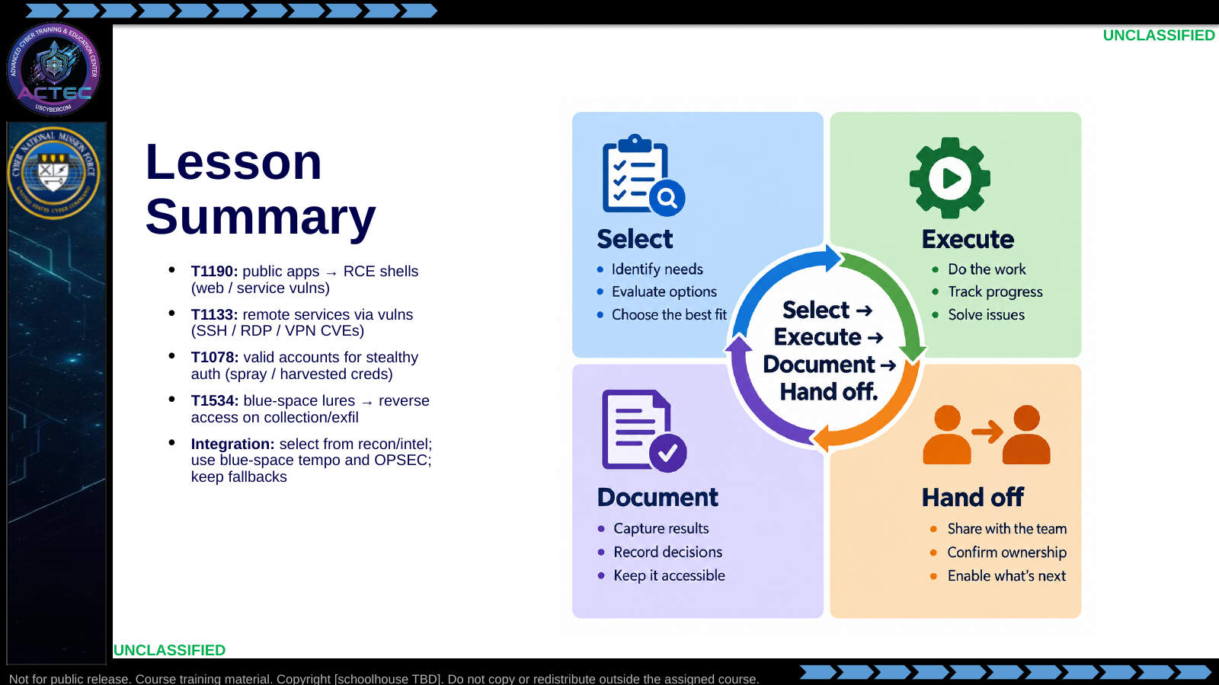  Slide 41: Lesson Summary  Duration: 2 min | Say: - "You now have four initial-access tools and a selection logic."  - "Exploits for exposed apps and remote services."  - "Credentials when you already own the password."  - "Lures when they keep stealing from you."  - "Integrate them; document them; hand them forward."  Show: - Tap each quadrant, then the hub.  Do: - Rapid-fire: instructor names an evidence type; class names the technique.  Ask (Q): What is the operational takeaway from this row?  Expected Response (A): Facilitation. Restate the Say/Do in operator terms. Do not invent a new teaching point.
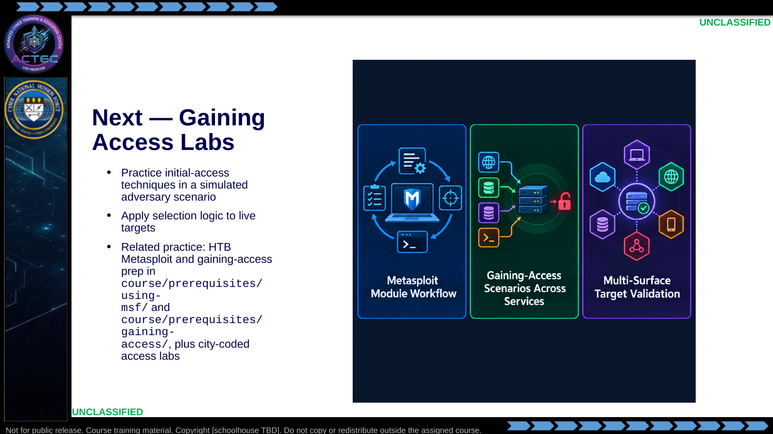  Slide 42: Next — Gaining Access Labs  Duration: 2 min | Say: - "Next you practice."  - "Expect to match banners, choose modules, and prove sessions."  - "Metasploit labs reinforce exploit execution."  - "Gaining-access practicals stretch across app and service surfaces."  - "Treat each box as an adversary node—select the technique from evidence."  Show: - Point to the lab boxes students will see on the schedule.  Do: - Preview the first lab brief location; break if scheduled.  Ask (Q): What is the operational takeaway from this row?  Expected Response (A): Facilitation. Restate the Say/Do in operator terms. Do not invent a new teaching point.
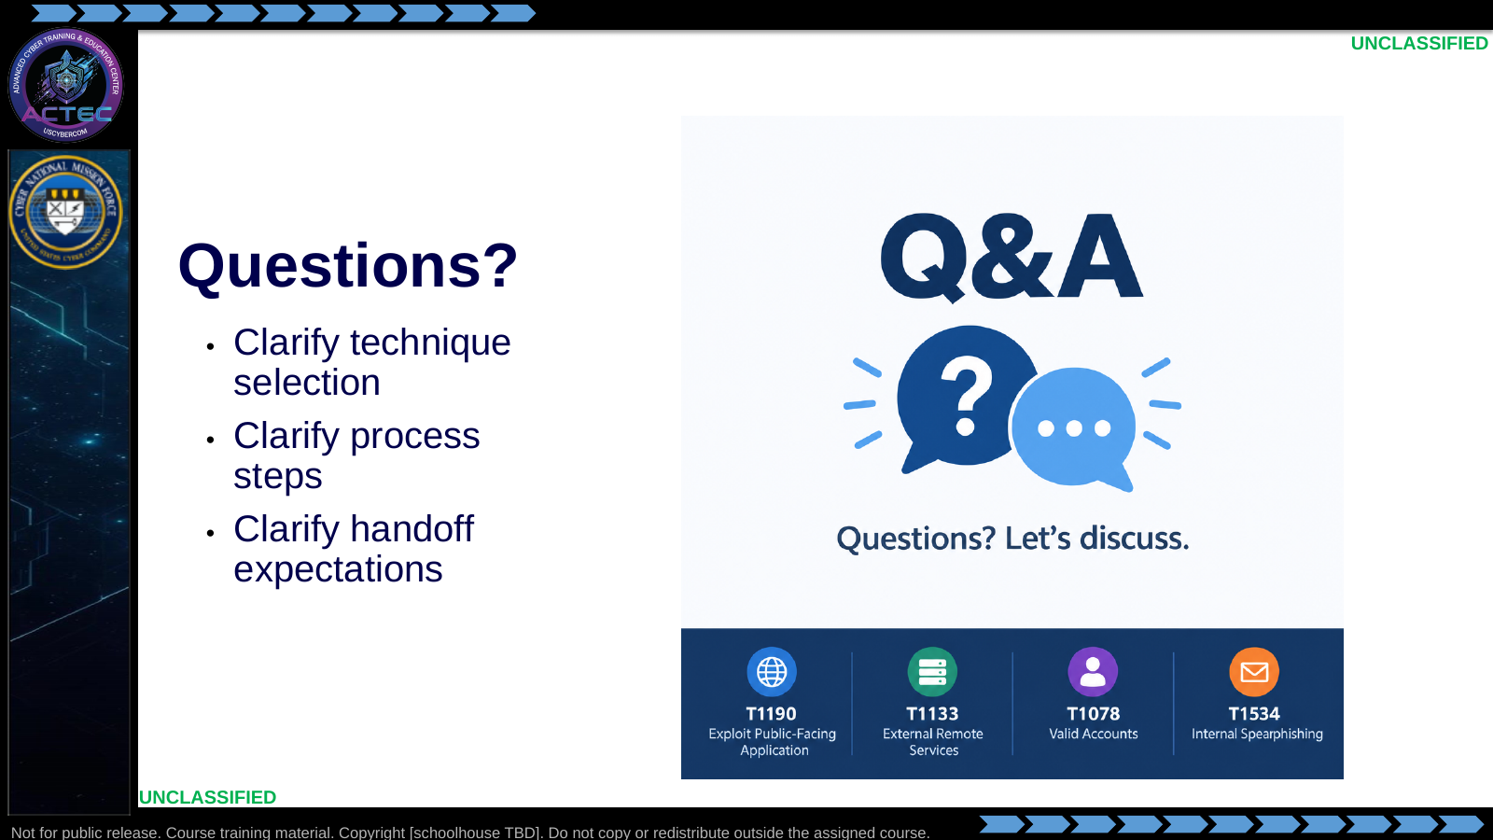  Slide 43: Questions?  Duration: 2 min | Say: - "Questions on T1190, T1133, T1078, T1534, or selection/handoff."  - "If it is lab logistics, bring it to the lab brief."  Show: - Leave the four IDs visible while taking questions.  Do: - Take questions; if none, cold-call one selection vignette before release.  Ask (Q): Which access technique would you select for the vignette, and what evidence makes it suitable?  Expected Response (A): Facilitation. Tie the choice to T1190, T1133, T1078, or T1534 and the evidence already on the board.  ---

4.3 Lesson summary
- B02.M03-gaining-access is executed as a generated lesson plan from this file.
- Assessment methods live on module.yaml; do not invent extra official ELOs.
- Later gaining-access labs continue from the selection logic this session collects.

4.4 Questions and check on learning
- Ask (Q): What is the difference between knowing a CVE exists and having a usable session?
- Expected Response (A): Facilitation. Use the Say/Do already on this row; do not force a single keyed answer.
- Ask (Q): What is the operational takeaway from this row?
- Expected Response (A): Facilitation. Restate the Say/Do in operator terms. Do not invent a new teaching point.
- Ask (Q): Where do access attempts most often fail: applicability, preparation, or execution?
- Expected Response (A): Facilitation. Use the Say/Do already on this row; do not force a single keyed answer.

5. Classification
Classification: UNCLASSIFIED

